UNITED STATES
SECURITIES AND EXCHANGE COMMISSION
Washington, D.C. 20549

FORM 8-K

CURRENT REPORT

Pursuant to Section 13 or 15(d) of
the Securities Exchange Act of 1934

Date of Report (Date of Earliest Event Reported): May 11, 2026

Green Dot Corporation
(Exact Name of the Registrant as Specified in Its Charter)

Delaware
(State or Other Jurisdiction of Incorporation)
001-34819 |  |  |  |  |  | 95-4766827
(Commission File Number) |  |  |  |  |  | (IRS Employer Identification No.)
 |  |  | 1675 N. Freedom Blvd (200 West) Building 1
 |  |  | Provo, |  |  | Utah |  |  | 84604 |  |  |  |  |  |  |  |  |  |  |  | (626) |  |  | 765-2000
(Address of Principal Executive Offices) |  |  |  |  |  |  |  |  |  |  |  |  |  |  |  |  |  | (Registrant's Telephone Number, Including Area Code)

Not Applicable
(Former Name or Former Address, If Changed Since Last Report)

Check the appropriate box below if the Form 8-K filing is intended to simultaneously satisfy the filing obligation of the registrant under any of the following provisions:

☑ Written communications pursuant to Rule 425 under the Securities Act (17 CFR 230.425)

☐ Soliciting material pursuant to Rule 14a-12 under the Exchange Act (17 CFR 240.14a-12)

☐ Pre-commencement communications pursuant to Rule 14d-2(b) under the Exchange Act (17 CFR 240.14d-2(b))

☐ Pre-commencement communications pursuant to Rule 13e-4(c) under the Exchange Act (17 CFR 240.13e-4(c))
Securities registered pursuant to Section 12(b) of the Act:
Title of each class: |  |  | Trading Symbol(s): |  |  | Name of each exchange on which registered:
Class A Common Stock, $0.001 par value |  |  | GDOT |  |  | New York Stock Exchange
Indicate by check mark whether the registrant is an emerging growth company as defined in Rule 405 of the Securities Act of 1933 (§ 230.405 of this chapter) or Rule 12b-2 of the Securities Exchange Act of 1934 (§ 240.12b-2 of this chapter).
Emerging growth company ☐
If an emerging growth company, indicate by check mark if the registrant has elected not to use the extended transition period for complying with any new or revised financial accounting standards provided pursuant to Section 13(a) of the Exchange Act. ☐

Item 2.02. Results of Operations and Financial Condition.
On May 11, 2026, Green Dot Corporation (the "Company") issued a press release announcing its financial results for the quarter ended March 31, 2026 and certain other financial information. A copy of the press release is furnished as Exhibit 99.01 to this Current Report and is incorporated herein by reference.
The Company has also prepared presentation materials to supplement the financial information contained in its press release. A copy of those materials is furnished as Exhibit 99.02 to this Current Report and is incorporated herein by reference.
The information furnished in this Current Report, including the exhibits hereto, shall not be deemed “filed” for purposes of Section 18 of the Securities Exchange Act of 1934, as amended (the “Exchange Act”), or incorporated by reference in any filing under the Securities Act of 1933, as amended, or the Exchange Act, except as shall be expressly set forth by specific reference in such a filing.
Item 9.01. Financial Statements and Exhibits.
(d) Exhibits.
Exhibit Number |  |  |  |  |  | Description of Exhibits
99.01 |  |  |  |  |  | Press release, dated May 11, 2026
99.02 |  |  |  |  |  | Supplemental earnings materials, dated May 11, 2026
104 |  |  |  |  |  | Cover Page Interactive Data File (embedded within the Inline XBRL document)

SIGNATURES
Pursuant to the requirements of the Securities Exchange Act of 1934, the registrant has duly caused this report to be signed on its behalf by the undersigned thereunto duly authorized.
GREEN DOT CORPORATION
By: |  |  |  |  |  | /s/ Jess Unruh
 |  |  |  |  |  | Jess Unruh
 |  |  |  |  |  | Chief Financial Officer

Date: May 11, 2026

Exhibit 99.01


Green Dot Reports First Quarter 2026 Results
Company Delivers Strong Performance as it Makes Progress Strengthening Fintech Platform and Bank and Prepares for Acquisition by Smith Ventures and CommerceOne
Provo, UT - May 11, 2026 - Green Dot Corporation (NYSE: GDOT) ("Green Dot"), a financial technology and bank holding company that delivers seamless banking and payments solutions to consumers and businesses of all sizes, today reported its financial results for the quarter ended March 31, 2026.
“Our results reflect our hard work to strengthen our platform and pipeline, accelerate momentum in our embedded finance division, and optimize our balance sheet,” said William Jacobs, Chief Executive Officer of Green Dot. “These efforts help ensure the company has a strong foundation and ample growth opportunity going forward, as well as in its next chapter with Smith Ventures and CommerceOne.”
Consolidated Results Summary
 |  |  |  |  |  |  | Three Months Ended March 31,
 |  |  |  |  |  |  |  |  | 2026 |  |  |  |  |  | 2025 |  |  |  |  |  | % Change
 |  |  |  |  |  |  |  |  | (In thousands, except per share data and percentages)
GAAP financial results
Total operating revenues |  |  |  |  |  |  |  |  | $ | 656,247 |  |  |  |  | $ | 558,874 |  |  |  |  | 17%
Net income |  |  |  |  |  |  |  |  | $ | 53,753 |  |  |  |  | $ | 25,773 |  |  |  |  | 109%
Diluted earnings per common share |  |  |  |  |  |  |  |  | $ | 0.93 |  |  |  |  | $ | 0.47 |  |  |  |  | 98%
Non-GAAP financial results1
Non-GAAP total operating revenues1 |  |  |  |  |  |  |  |  | $ | 652,032 |  |  |  |  | $ | 555,964 |  |  |  |  | 17%
Adjusted EBITDA1 |  |  |  |  |  |  |  |  | $ | 102,440 |  |  |  |  | $ | 90,559 |  |  |  |  | 13%
Adjusted EBITDA/Non-GAAP total operating revenues (adjusted EBITDA margin) |  |  |  |  |  |  |  |  | 15.7 |  | % |  |  |  | 16.3 |  | % |  |  |  | (0.6)%
Non-GAAP net income1 |  |  |  |  |  |  |  |  | $ | 64,970 |  |  |  |  | $ | 58,407 |  |  |  |  | 11%
Non-GAAP diluted earnings per share1 |  |  |  |  |  |  |  |  | $ | 1.12 |  |  |  |  | $ | 1.06 |  |  |  |  | 6%
Cash at the holding company was approximately $34 million as of March 31, 2026.

1 |  |  | Reconciliations of total operating revenues to non-GAAP total operating revenues, net income to adjusted EBITDA, net income to non-GAAP net income, and diluted earnings per share to non-GAAP diluted earnings per share, respectively, are provided in the tables immediately following the unaudited consolidated financial statements. Additional information about the Company's non-GAAP financial measures can be found under the caption “About Non-GAAP Financial Measures” below.

Key Metrics
The following table shows Green Dot's quarterly key business metrics for each of the last five calendar quarters on a consolidated basis and by each of its reportable segments. Please refer to Green Dot’s latest Annual Report on Form 10-K for a description of the key business metrics, as well as additional information regarding how Green Dot organizes its business by segment.
 |  |  |  |  |  | 2026 |  |  |  |  |  | 2025
 |  |  |  |  |  | Q1 |  |  |  |  |  | Q4 |  |  | Q3 |  |  | Q2 |  |  | Q1
 |  |  |  |  |  | (In millions)
Consolidated *
Gross dollar volume |  |  |  |  |  | $ | 43,217 |  |  |  |  | $ | 40,526 |  | $ | 39,505 |  | $ | 38,545 |  | $ | 37,252
Number of active accounts |  |  |  |  |  | 3.43 |  |  |  |  |  | 3.42 |  |  | 3.51 |  |  | 3.48 |  |  | 3.58
Purchase volume |  |  |  |  |  | $ | 4,706 |  |  |  |  | $ | 4,705 |  | $ | 4,736 |  | $ | 4,991 |  | $ | 5,113
B2B Services
Gross dollar volume |  |  |  |  |  | $ | 39,338 |  |  |  |  | $ | 36,923 |  | $ | 35,868 |  | $ | 34,620 |  | $ | 33,014
Number of active accounts |  |  |  |  |  | 1.91 |  |  |  |  |  | 1.93 |  |  | 1.89 |  |  | 1.81 |  |  | 1.78
Purchase volume |  |  |  |  |  | $ | 1,917 |  |  |  |  | $ | 2,035 |  | $ | 2,006 |  | $ | 2,000 |  | $ | 1,986
Consumer Services
Gross dollar volume |  |  |  |  |  | $ | 3,879 |  |  |  |  | $ | 3,603 |  | $ | 3,637 |  | $ | 3,925 |  | $ | 4,238
Number of active accounts |  |  |  |  |  | 1.52 |  |  |  |  |  | 1.49 |  |  | 1.62 |  |  | 1.67 |  |  | 1.80
Direct deposit active accounts |  |  |  |  |  | 0.38 |  |  |  |  |  | 0.39 |  |  | 0.40 |  |  | 0.41 |  |  | 0.41
Purchase volume |  |  |  |  |  | $ | 2,789 |  |  |  |  | $ | 2,670 |  | $ | 2,730 |  | $ | 2,991 |  | $ | 3,127
Money Movement
Number of cash transfers |  |  |  |  |  | 7.02 |  |  |  |  |  | 7.39 |  |  | 7.43 |  |  | 7.52 |  |  | 7.51
Number of tax refunds processed |  |  |  |  |  | 7.78 |  |  |  |  |  | 0.11 |  |  | 0.20 |  |  | 3.73 |  |  | 7.98
* Represents the sum of Green Dot's Consumer Services and B2B (as defined herein) Services segments.

"We had a strong start to the year led by performance in our tax processing business, and outperformance in several of our other divisions," said Jess Unruh, Chief Financial Officer of Green Dot. "As we continue making investments that support top-line growth, we are also building a culture of cost discipline that helps drive our bottom-line results, as we benefited from modestly lower operating expenses in the quarter.”

Proposed Transactions with CommerceOne Financial Corporation and Smith Ventures, LLC
On November 24, 2025, Green Dot announced that it entered into agreements to be acquired by affiliates of Smith Ventures, LLC (“Smith Ventures”) and CommerceOne Financial Corporation (“CommerceOne”). Upon closing of these proposed transactions, Smith Ventures will acquire and privatize Green Dot’s non-bank financial technology business assets and operations (the “FinTech business”), which will continue running as an independent and growth-focused fintech and embedded finance company. Additionally, upon closing of these proposed transactions, CommerceOne will acquire Green Dot Bank and its associated assets and operations, and the combined organization will serve as the FinTech business’s exclusive sponsor bank.
The closing of the transactions remains subject to the receipt of required shareholder and regulatory approvals and the satisfaction of other customary closing conditions. The parties received early

termination of the waiting period under the Hart-Scott-Rodino Act and have filed regulatory applications to all applicable U.S. federal and state bank authorities.
As a result of Green Dot’s proposed transactions with CommerceOne and Smith Ventures, Green Dot will not be hosting an earnings conference call nor providing 2026 financial guidance in conjunction with this earnings release. For further detail and discussion of Green Dot’s financial performance, please refer to the additional materials made available in the Investor Relations section of Green Dot's website at http://ir.greendot.com/ and Green Dot’s Annual Report on Form 10-K for the year ended December 31, 2025 filed with the Securities and Exchange Commission, as amended.

Discussion of Segment Results
Over the last several years, Green Dot has strengthened its foundation for sustainable growth, and it is beginning to see those efforts pay off. Investments to enhance its platform and improve enterprise operations will help position the FinTech business, comprised of the consumer and embedded finance divisions and operations, to be a growth-enabled organization upon being acquired and taken private by Smith Ventures and a valuable partner to Green Dot Bank and CommerceOne for years to come.
2025 was a strong year for new business growth, with new partnerships across the B2B, money movement and consumer divisions. In the first quarter of 2026, Green Dot maintained a strong pipeline of prospective partners that continue to present substantial growth opportunities via its fee-based transaction revenues and through deposits that are strategically invested in high-quality, interest-bearing assets. Optimizing balance sheet profitability has remained an area of focus, and Green Dot's efforts and progress in this area are reflected in the results as well. Green Dot sees additional opportunities to continue strengthening its earnings profile and balance sheet, as it enhances its investment mix and grows deposits from the embedded finance offerings, particularly in the BaaS business.
As revenue momentum improved, Green Dot continued making progress in its multi-year efforts to strengthen its operating and regulatory infrastructures and drive improved efficiency. The team remains focused on strengthening the technology platform and simplifying operations to make Green Dot a more innovative, nimble platform and partner. Green Dot also remains committed to investing in regulatory infrastructure and believes it is seeing the benefits of that work materialize in pipelines as prospective partners prioritize compliance and regulatory support when selecting a platform partner.
B2B Services Segment
The B2B Services segment includes the BaaS division, powered by ARC, Green Dot's end-to-end embedded finance platform, and the rapid! employer solutions business. Revenue growth continues to be led by a significant BaaS partner, along with growth across the broader BaaS portfolio. Active accounts in the BaaS channel continue to increase as Green Dot works with new and existing partners to launch products and drive engagement. Green Dot expects its pipeline of launches and other opportunities to support continued revenue and deposit growth.
In employer services (rapid!), Green Dot is repositioning the business by aligning the salesforce, improving efficiency, lowering expenses, and focusing more on Earned Wage Access ("EWA"), where it sees meaningful growth potential. Declines in purchase volume continued to moderate in the quarter, suggesting these changes are gaining traction and helped drive higher profitability per active account. Green Dot reinvested a portion of the cost savings into EWA capabilities, sales support, and integrations with new payroll platforms to pursue additional opportunities. Green Dot remains optimistic about EWA, given its strong demand and attractive margins.
Overall, B2B segment profit grew year-over-year, driven by higher demand and activity in BaaS. BaaS margins declined modestly due to its revenue mix, particularly the growth of a significant partner.

Margins in rapid! employer services improved from the prior year period, primarily due to cost initiatives taken over the last several quarters.
Money Movement Services Segment
The Money Movement Services segment includes the tax processing and money processing businesses. Revenue growth was driven by tax processing, supported by a strong start to the tax season and the launch of a significant new franchise partner.
Green Dot has invested in its tax operations over time to strengthen its position as a technology and service leader, and the successful launch of this new partner reinforces that. Green Dot has also expanded product availability, especially taxpayer advance programs, which continue to see strong momentum and customer adoption.
Money processing revenue was affected by softness in the Consumer segment’s active account base. With respect to third-party transactions, excluding two partners with declines in low-revenue transactions, volume increased in the low- to mid-single digits in the quarter, reflecting continued success in adding partners that value the breadth and convenience of the network.
With Money Processing and BaaS operations more closely integrated, Green Dot expects to maintain a healthy pipeline of potential partners. Combined with recent cash transfer and digital disbursement launches, a solid schedule of upcoming launches, including Stripe, and moderating declines in the Consumer segment, Green Dot believes the business is well positioned to improve momentum from prior quarters.
Margins in Money Movement Services were affected by modest declines in both money processing and tax processing. Money processing margins were pressured by ongoing revenue headwinds, while tax processing margin pressure primarily reflected revenue mix, despite solid profit growth in that business.
Consumer Services Segment
The Consumer Services segment continued to face pressure from ongoing headwinds in traditional retail distribution and reduced marketing spend supporting the direct-to-consumer channel.
Retail channel performance reflected continued consumer shift to digital banking solutions instead of purchasing cards at retail locations. Green Dot partially mitigated these impacts through expansion within Financial Service Centers ("FSCs"), including the mid-2024 launch of PLS Financial Services, which contributed to a reduced rate of decline in active accounts and revenue. FSC partners, unlike the traditional retail relationships, are focused on digital and embedded solutions aligned with Green Dot's BaaS offerings, with the goal of driving deeper, more meaningful banking relationships with customers. Green Dot is preparing to introduce several new FSC partners in 2026, which are expected to help mitigate challenges faced by traditional retail channels. Additionally, there has been a noticeable increase in interest from traditional retail partners regarding digital and embedded solutions. This development is anticipated to enhance engagement and activity across the retail customer base.
Revenue declines in the direct-to-consumer channel were largely attributable to reduced marketing investment during the second half of 2024 and much of 2025, as Green Dot prioritized achieving acceptable returns on marketing investments and advancing its efforts to modernize the user experience and develop new feature functionality. As these initiatives have progressed, Green Dot increased marketing spend in the fourth quarter of 2025 and saw a modest sequential increase in actives in the first quarter of 2026. Green Dot believes the improved user experience, added functionality, and a more consistent marketing cadence can position the business to return to growth.

Segment margins and operating income declined year-over-year, reflecting lower revenue and higher expenses. Despite declines in active accounts and revenue, key metrics such as volume and revenue per active continued to grow.
Corporate and Other Segment
Similar to last quarter, Corporate and Other segment revenues, consisting primarily of interest income net of partner interest sharing, increased sharply year-over-year. Results benefitted from interest rate cuts during the second half of 2025, which improved the spread between yields earned on cash and investments and amounts shared with partners. Additionally, Green Dot repositioned a portion of its securities portfolio in 2025 and increased investment in high-grade floating-rate securities, contributing to improved yields at Green Dot Bank. Corporate expenses increased modestly as Green Dot made selective investments in areas such as compliance and risk management, but corporate expenses as a percentage of revenue declined year-over-year.

Forward-Looking Statements
This earnings release contains statements that constitute “forward-looking statements” within the meaning of, and subject to the protections of, Section 27A of the Securities Act of 1933, as amended, and Section 21E of the Securities Exchange Act of 1934, as amended. All statements other than statements of historical fact are statements that could be deemed to be forward-looking statements. These forward-looking statements include, but are not limited to, certain plans, expectations, goals, projections, and statements about the benefits or costs of the proposed transactions, the plans, objectives, expectations and intentions of Green Dot, CommerceOne, and affiliates of Smith Ventures, including future financial and operating results (including the anticipated impact of the proposed transactions), statements related to the expected timing of the completion of the proposed transactions, the plans, objectives, expectations and intentions of Compass Sub North, Inc., a newly formed Delaware corporation and a direct, wholly-owned subsidiary of CommerceOne (to be renamed “CommerceOne Financial Corporation” as part of the proposed transactions), following the consummation of the proposed transactions (the “combined company” or “New CommerceOne”) described herein, and other statements that are not historical facts. You can identify these forward-looking statements through the use of words such as “expects,” “anticipates,” “targets,” “goals,” “projects,” “predicts,” “forecasts,” “intends,” “plans,” “believes,” “seeks,” “estimates,” “continues,” “endeavors,” “strives,” “may” and “assumes,” variations of such words and similar expressions of the future or otherwise regarding the outlook for Green Dot’s, CommerceOne’s or the combined company’s future businesses and financial performance and/or the performance of the banking industry and economy in general.
Prospective investors are cautioned that any such forward-looking statements are not guarantees of future performance and involve known and unknown risks and uncertainties which may cause the actual results, performance or achievements of Green Dot, CommerceOne or the combined company to be materially different from the future results, performance or achievements expressed or implied by such forward-looking statements. Forward-looking statements are based on the information known to, and current beliefs and expectations of, Green Dot or CommerceOne and are subject to significant risks and uncertainties. Actual results may differ materially from those contemplated by such forward-looking statements. A number of factors could cause actual results to differ materially from those contemplated by the forward-looking statements in this communication. Many of these factors are beyond Green Dot’s, CommerceOne’s or the combined company’s ability to control or predict, and there is no assurance that any list of risks and uncertainties or risk factors is complete. These factors include, among others, (1) the risk that the cost savings and synergies from the proposed transaction may not be fully realized or may take longer than anticipated to be realized, (2) disruption to Green Dot’s

business and to CommerceOne’s business as a result of the announcement and pendency of the proposed transaction, (3) the risk that the integration of Green Dot’s and CommerceOne’s respective businesses and operations, or the separation of Green Dot’s non-bank fintech businesses from Green Dot Bank, will be materially delayed or will be more costly or difficult than expected, including as a result of unexpected factors or events, (4) the failure to satisfy the conditions to the closing of the transactions among Green Dot, CommerceOne and Smith Ventures, including the failure to obtain the necessary approvals by the stockholders of Green Dot or CommerceOne, (5) the amount of the costs, fees, expenses and charges related to the transactions, (6) the ability by each of Green Dot, CommerceOne and Smith Ventures to obtain required governmental approvals of the proposed transactions on the timeline expected, or at all, and the risk that such approvals may result in the imposition of conditions that could adversely affect the combined company after the closing of the proposed transaction or adversely affect the expected benefits of the proposed transactions, (7) reputational risk and the reaction of Green Dot’s or CommerceOne’s customers, suppliers, employees or other business partners to the proposed transactions, (8) challenges retaining or hiring key personnel following the proposed transactions, (9) any unexpected delay in closing the proposed transactions or the occurrence of any event, change or other circumstances that could give rise to the termination of the Merger Agreement or Separation Agreement, (10) the dilution caused by the issuance of shares of the combined company’s common stock in the transaction, (11) the possibility that the proposed transactions may be more expensive to complete than anticipated, including as a result of unexpected factors or events, (12) risks related to management and oversight of the business and operations of the combined company and the separation of Green Dot’s non-bank fintech business from Green Dot Bank and the combined company, (13) the possibility the combined company is subject to additional regulatory requirements or consent orders as a result of the proposed transactions, (14) the outcome of any legal or regulatory proceedings or governmental inquiries or investigations that may be currently pending or later instituted against Green Dot, CommerceOne or the combined company, and (15) general competitive, economic, political, regulatory and market conditions and other factors that may affect future results of Green Dot, CommerceOne and the combined company, including changes in asset quality and credit risk; the inability to sustain or achieve revenue and earnings growth; changes in interest rates and capital markets; inflation; customer borrowing, repayment, investment and deposit practices; the ability to raise or maintain liquidity, funding, and capital; the impact, extent and timing of technological changes; capital management activities; fraudulent or other illegal activity involving the products and services of Green Dot, CommerceOne or the combined company; cybersecurity risks, including cyber-attacks or security breaches; fluctuations in operating results; changes in legislation, regulation, policies or administrative practices and the ability to comply with such changes in a timely manner; and changes in the monetary and fiscal policies of the U.S. Government. Additional factors which could affect future results of Green Dot can be found in Green Dot’s filings with the Securities and Exchange Commission (the “SEC”), including in Green Dot’s Annual Report on Form 10-K for the year ended December 31, 2025, as amended, under the captions “Forward-Looking Statements” and “Risk Factors,” and Green Dot’s Quarterly Reports on Form 10-Q and Current Reports on Form 8-K. Undue reliance should not be placed on any forward-looking statements, which are based on current expectations and speak only as of the date that they are made. Green Dot, CommerceOne and Smith Ventures do not assume any obligation to update any forward-looking statements as a result of new information, future developments or otherwise, except as otherwise may be required by law.

Important Information About the Transaction and Where to Find It
New CommerceOne filed a registration statement on Form S-4 (File No. 333-293326) with the SEC on February 10, 2026,1 as amended on April 7, 2026,2 May 1, 20263 and May 7, 20264 to register the shares of New CommerceOne common stock that will be issued to CommerceOne stockholders and Green Dot stockholders in connection with the proposed transactions. The registration statement includes a proxy statement of Green Dot and CommerceOne that also constitutes a prospectus of New CommerceOne. The registration statement was declared effective on May 8, 2026, at which time Green Dot filed a definitive proxy statement and New CommerceOne filed a final prospectus. Green Dot and New CommerceOne expect to commence mailing of the proxy statement/prospectus to their respective shareholders on or about May 15, 2026. INVESTORS AND SECURITY HOLDERS ARE URGED TO READ THE REGISTRATION STATEMENT AND PROXY STATEMENT/PROSPECTUS (AND ANY OTHER DOCUMENTS FILED WITH THE SEC IN CONNECTION WITH THE PROPOSED TRANSACTIONS OR INCORPORATED BY REFERENCE INTO THE PROXY STATEMENT/PROSPECTUS) BECAUSE SUCH DOCUMENTS CONTAIN OR WILL CONTAIN IMPORTANT INFORMATION REGARDING THE PROPOSED TRANSACTIONS AND RELATED MATTERS.
Investors and security holders may obtain free copies of these documents and other documents filed with the SEC by Green Dot or New CommerceOne through the website maintained by the SEC at http://www.sec.gov. Documents filed with the SEC by Green Dot will also be available free of charge by contacting the investor relations department of Green Dot at IR@greendot.com or by clicking on “Financial Information” in the Investor Relations section of Green Dot's website at http://ir.greendot.com/.
Before making any voting or investment decision, investors and security holders of Green Dot and CommerceOne are urged to read carefully the entire registration statement and proxy statement/prospectus, including any amendments thereto, because they contain or will contain important information about the proposed transactions. Free copies of these documents may be obtained as described above.

Participants in Solicitation
Green Dot and CommerceOne and certain of their respective directors and executive officers and other members of management and employees may be deemed to be participants in the solicitation of proxies from Green Dot’s stockholders in respect of the proposed transactions under the rules of the SEC. Information about the directors and executive officers of Green Dot and CommerceOne is included in the registration statement. Information regarding Green Dot’s directors and executive officers is also available in Green Dot’s Amendment No. 1 to the Annual Report on Form 10-K for the year ended December 31, 2025 (the “Green Dot 10-K/A”),5 which was filed with the SEC on April 30, 2026, and in other documents subsequently filed by Green Dot with the SEC, which can be obtained free of charge through the website maintained by the SEC at http://www.sec.gov. Any changes in the holdings of Green Dot’s securities by Green Dot’s directors or executive officers from the amounts described in the Green Dot 10-K/A have been or will be reflected on Initial Statements of Beneficial Ownership of Securities on Form 3 or on Statements of Change in Ownership on Form 4 filed with the SEC subsequent to the filing date of the Green Dot 10-K/A and are available at the SEC’s website at www.sec.gov.
1 Available at https://www.sec.gov/Archives/edgar/data/2103884/000114036126004471/ny20062675x1_s4.htm.
2 Available at https://www.sec.gov/Archives/edgar/data/2103884/000114036126013676/ny20062675x2_s4a.htm.
3 Available at https://www.sec.gov/Archives/edgar/data/2103884/000114036126018596/ny20062675x4_s4a.htm.
4 Available at https://www.sec.gov/Archives/edgar/data/2103884/000114036126019383/ny20062675x6_s4a.htm.
5 Available at https://www.sec.gov/ix?doc=/Archives/edgar/data/0001386278/000138627826000023/gdot-20251231.htm.

No Offer or Solicitation
This communication relates to the proposed transactions and is for informational purposes only and is not intended to, and does not constitute an offer to sell or the solicitation of an offer to buy any securities or a solicitation of any vote or approval, nor shall there be any sale of securities in any jurisdiction in which such offer, solicitation or sale would be unlawful prior to registration or qualification under the securities laws of any such jurisdiction. No offer of securities shall be made except by means of a prospectus meeting the requirements of Section 10 of the Securities Act of 1933, as amended.

About Non-GAAP Financial Measures
To supplement Green Dot's consolidated financial statements presented in accordance with accounting principles generally accepted in the United States of America (GAAP), Green Dot uses measures of operating results that are adjusted for, among other things, non-operating net interest income and expense; other non-interest investment income earned by its bank; income tax benefit and expense; depreciation and amortization, including amortization of acquired intangibles; certain legal settlement gains and charges; stock-based compensation and related employer payroll taxes; changes in the fair value of contingent consideration; transaction costs from acquisitions or divestitures; amortization attributable to deferred financing costs; impairment charges; extraordinary severance expenses; earnings or losses from equity method investments; changes in the fair value of loans held for sale; commissions and certain processing-related costs associated with embedded finance products and services where Green Dot does not control customer acquisition; realized gains and losses on available-for-sale investment securities; restructuring and other charges; other charges and income not reflective of ongoing operating results; and income tax effects. This earnings release includes non-GAAP total operating revenues, adjusted EBITDA, non-GAAP net income, and non-GAAP diluted earnings per share. These non-GAAP financial measures are not calculated or presented in accordance with, and are not alternatives or substitutes for, financial measures prepared in accordance with GAAP, and should be read only in conjunction with Green Dot's financial measures prepared in accordance with GAAP. Green Dot's non-GAAP financial measures may be different from similarly-titled non-GAAP financial measures used by other companies. Green Dot believes that the presentation of non-GAAP financial measures provides useful information to management and investors regarding underlying trends in its consolidated financial condition and results of operations. Green Dot's management regularly uses these supplemental non-GAAP financial measures internally to understand, manage and evaluate Green Dot's business and make operating decisions. For additional information regarding Green Dot's use of non-GAAP financial measures and the items excluded by Green Dot from one or more of its historic non-GAAP financial measures, investors are encouraged to review the reconciliations of Green Dot's historic non-GAAP financial measures to the comparable GAAP financial measures, which are attached to this earnings release, and which can be found by clicking on “Financial Information” in the Investor Relations section of Green Dot's website at http://ir.greendot.com/.

About Green Dot
Green Dot Corporation (NYSE: GDOT) is a financial technology platform and registered bank holding company that builds banking and payment solutions to create value, retain and reward customers, and accelerate growth for businesses of all sizes. For more than two decades, Green Dot has delivered financial tools and services that address the most pressing financial needs of consumers and businesses, and that transform the way people and businesses manage and move money.

Green Dot delivers a broad spectrum of financial products to consumers and businesses through its portfolio of brands, including: GO2bank, a leading digital and mobile bank account offering simple,

secure and useful banking for Americans living paycheck to paycheck; the Green Dot Network (“GDN”) of more than 90,000 retail distribution and cash access locations nationwide; Arc by Green Dot, the single-source embedded finance platform combining all of Green Dot’s secure banking and money processing capabilities to power businesses at all stages of growth; rapid! wage and disbursements solutions, providing pay card and earned wage access services to more than 7,000 businesses and their employees; and Santa Barbara TPG (“SBTPG”), the company’s tax division, which processes on average approximately 13 million tax refunds annually.

Founded in 1999, Green Dot has managed more than 80 million accounts to date both directly and through its partners. Green Dot Bank is a subsidiary of Green Dot Corporation and member of the FDIC. For more information about Green Dot’s products and services, please visit www.greendot.com.

Contacts
Investor Relations:
IR@greendot.com
Media Relations:
Alison Lubert
SVP, Head of Corporate Communications
alubert@greendotcorp.com

GREEN DOT CORPORATION
CONSOLIDATED BALANCE SHEETS
 |  |  | March 31, 2026 |  |  |  |  |  | December 31, 2025
 |  |  | (unaudited)
Assets |  |  | (In thousands, except par value)
Current assets:
Unrestricted cash and cash equivalents |  |  | $ | 1,646,382 |  |  |  |  | $ | 1,421,690
Restricted cash |  |  | 31 |  |  |  |  |  | 44
Settlement assets |  |  | 879,485 |  |  |  |  |  | 947,497
Accounts receivable, net |  |  | 196,342 |  |  |  |  |  | 197,248
Prepaid expenses and other assets |  |  | 106,924 |  |  |  |  |  | 73,275
Income tax receivable |  |  | 422 |  |  |  |  |  | 589
Total current assets |  |  | 2,829,586 |  |  |  |  |  | 2,640,343
Investment securities available-for-sale, at fair value |  |  | 2,969,954 |  |  |  |  |  | 2,467,843
Loans to bank customers, net of allowance for credit losses of $21,645 and $21,053 as of March 31, 2026 and December 31, 2025, respectively |  |  | 47,464 |  |  |  |  |  | 55,700
Prepaid expenses and other assets |  |  | 154,327 |  |  |  |  |  | 154,567
Property, equipment, and internal-use software, net |  |  | 198,978 |  |  |  |  |  | 198,352
Operating lease right-of-use assets |  |  | 999 |  |  |  |  |  | 1,053
Deferred expenses |  |  | 727 |  |  |  |  |  | 789
Net deferred tax assets |  |  | 79,585 |  |  |  |  |  | 92,188
Goodwill and intangible assets |  |  | 368,995 |  |  |  |  |  | 374,401
Total assets |  |  | $ | 6,650,615 |  |  |  |  | $ | 5,985,236
Liabilities and Stockholders’ Equity
Current liabilities:
Accounts payable |  |  | $ | 101,432 |  |  |  |  | $ | 114,714
Deposits |  |  | 4,528,541 |  |  |  |  |  | 4,416,294
Obligations to customers |  |  | 294,643 |  |  |  |  |  | 284,978
Settlement obligations |  |  | 62,048 |  |  |  |  |  | 52,916
Other accrued liabilities |  |  | 150,941 |  |  |  |  |  | 153,752
Operating lease liabilities |  |  | 375 |  |  |  |  |  | 325
Deferred revenue |  |  | 4,351 |  |  |  |  |  | 4,224
Federal Home Loan Bank advances |  |  | 500,000 |  |  |  |  |  | —
Income tax payable |  |  | 2,433 |  |  |  |  |  | 2,366
Total current liabilities |  |  | 5,644,764 |  |  |  |  |  | 5,029,569
Other accrued liabilities |  |  | 203 |  |  |  |  |  | 282
Operating lease liabilities |  |  | 1,508 |  |  |  |  |  | 1,599
Notes payable |  |  | 63,640 |  |  |  |  |  | 63,541
Total liabilities |  |  | 5,710,115 |  |  |  |  |  | 5,094,991
Stockholders’ equity:
Class A common stock, $0.001 par value; 100,000 shares authorized as of March 31, 2026 and December 31, 2025; 56,661 and 55,565 shares issued and outstanding as of March 31, 2026 and December 31, 2025, respectively |  |  | 57 |  |  |  |  |  | 56
Additional paid-in capital |  |  | 427,915 |  |  |  |  |  | 427,477
Retained earnings |  |  | 698,489 |  |  |  |  |  | 644,736
Accumulated other comprehensive loss |  |  | (185,961) |  |  |  |  |  | (182,024)
Total stockholders’ equity |  |  | 940,500 |  |  |  |  |  | 890,245
Total liabilities and stockholders’ equity |  |  | $ | 6,650,615 |  |  |  |  | $ | 5,985,236

GREEN DOT CORPORATION
CONSOLIDATED STATEMENTS OF OPERATIONS
(UNAUDITED)
 |  |  |  |  | Three Months Ended March 31,
 |  |  |  |  |  |  | 2026 |  |  |  |  |  | 2025
 |  |  |  |  |  |  | (In thousands, except per share data)
Operating revenues:
Card revenues and other fees |  |  |  |  |  |  | $ | 448,675 |  |  |  |  | $ | 375,953
Cash processing revenues |  |  |  |  |  |  | 136,371 |  |  |  |  |  | 113,373
Interchange revenues |  |  |  |  |  |  | 43,959 |  |  |  |  |  | 47,919
Interest income, net |  |  |  |  |  |  | 27,242 |  |  |  |  |  | 21,629
Total operating revenues |  |  |  |  |  |  | 656,247 |  |  |  |  |  | 558,874
Operating expenses:
Sales and marketing expenses |  |  |  |  |  |  | 59,313 |  |  |  |  |  | 59,688
Compensation and benefits expenses |  |  |  |  |  |  | 59,771 |  |  |  |  |  | 66,214
Processing expenses |  |  |  |  |  |  | 374,594 |  |  |  |  |  | 285,317
Other general and administrative expenses |  |  |  |  |  |  | 93,449 |  |  |  |  |  | 86,910
Restructuring and other charges |  |  |  |  |  |  | 82 |  |  |  |  |  | —
Total operating expenses |  |  |  |  |  |  | 587,209 |  |  |  |  |  | 498,129
Operating income |  |  |  |  |  |  | 69,038 |  |  |  |  |  | 60,745
Interest expense, net |  |  |  |  |  |  | 1,576 |  |  |  |  |  | 1,386
Other income (expense), net |  |  |  |  |  |  | 177 |  |  |  |  |  | (25,704)
Income before income taxes |  |  |  |  |  |  | 67,639 |  |  |  |  |  | 33,655
Income tax expense |  |  |  |  |  |  | 13,886 |  |  |  |  |  | 7,882
Net income |  |  |  |  |  |  | $ | 53,753 |  |  |  |  | $ | 25,773
Basic earnings per common share: |  |  |  |  |  |  | $ | 0.96 |  |  |  |  | $ | 0.47
Diluted earnings per common share |  |  |  |  |  |  | $ | 0.93 |  |  |  |  | $ | 0.47
Basic weighted-average common shares issued and outstanding: |  |  |  |  |  |  | 55,743 |  |  |  |  |  | 54,361
Diluted weighted-average common shares issued and outstanding: |  |  |  |  |  |  | 58,016 |  |  |  |  |  | 55,282

GREEN DOT CORPORATION
CONSOLIDATED STATEMENTS OF CASH FLOWS
(UNAUDITED)
 |  |  | Three Months Ended March 31,
 |  |  | 2026 |  |  |  |  |  | 2025
 |  |  | (In thousands)
Operating activities
Net income |  |  | $ | 53,753 |  |  |  |  | $ | 25,773
Adjustments to reconcile net income to net cash provided by operating activities:
Depreciation and amortization of property, equipment and internal-use software |  |  | 18,134 |  |  |  |  |  | 15,184
Amortization of intangible assets |  |  | 5,147 |  |  |  |  |  | 5,200
Provision for uncollectible overdrawn accounts from purchase transactions |  |  | 2,556 |  |  |  |  |  | 2,864
Provision for loan losses |  |  | 11,110 |  |  |  |  |  | 11,127
Stock-based compensation |  |  | 4,494 |  |  |  |  |  | 3,021
Losses in equity method investments |  |  | 1,420 |  |  |  |  |  | 2,846
Realized loss on available-for-sale investment securities |  |  | — |  |  |  |  |  | 24,497
Amortization of premium and discount on available-for-sale investment securities |  |  | 959 |  |  |  |  |  | (513)
Impairment of long-lived assets |  |  | 331 |  |  |  |  |  | 61
Other |  |  | 6,012 |  |  |  |  |  | (1,499)
Changes in operating assets and liabilities:
Accounts receivable, net |  |  | (1,650) |  |  |  |  |  | 499
Prepaid expenses and other assets |  |  | 1,380 |  |  |  |  |  | 1,720
Deferred expenses |  |  | 62 |  |  |  |  |  | 257
Accounts payable and other accrued liabilities |  |  | (22,854) |  |  |  |  |  | 11,988
Deferred revenue |  |  | 48 |  |  |  |  |  | (1,695)
Income tax receivable/payable |  |  | 14,146 |  |  |  |  |  | 7,713
Other, net |  |  | 13 |  |  |  |  |  | (322)
Net cash provided by operating activities |  |  | 95,061 |  |  |  |  |  | 108,721
Investing activities
Purchases of available-for-sale investment securities |  |  | (549,768) |  |  |  |  |  | (80,741)
Proceeds from maturities of available-for-sale securities |  |  | 41,495 |  |  |  |  |  | 54,520
Proceeds from sales and calls of available-for-sale securities |  |  | — |  |  |  |  |  | 287
Payments for property, equipment and internal-use software |  |  | (19,032) |  |  |  |  |  | (19,418)
Net changes in loans |  |  | (16,093) |  |  |  |  |  | (17,631)
Other investing activities |  |  | (23,199) |  |  |  |  |  | (474)
Net cash used in investing activities |  |  | (566,597) |  |  |  |  |  | (63,457)
Financing activities
Borrowings on notes payable |  |  | — |  |  |  |  |  | 14,860
Net borrowings from Federal Home Loan Bank |  |  | 500,000 |  |  |  |  |  | —
Proceeds from ESPP purchases |  |  | 820 |  |  |  |  |  | —
Taxes paid related to net share settlement of equity awards |  |  | (4,875) |  |  |  |  |  | (2,429)
Net changes in deposits |  |  | 112,415 |  |  |  |  |  | 159,766
Net changes in settlement assets and obligations to customers |  |  | 87,855 |  |  |  |  |  | (36,586)
Deferred financing costs |  |  | — |  |  |  |  |  | (422)
Net cash provided by financing activities |  |  | 696,215 |  |  |  |  |  | 135,189
Net increase in unrestricted cash, cash equivalents and restricted cash |  |  | 224,679 |  |  |  |  |  | 180,453
Unrestricted cash, cash equivalents and restricted cash, beginning of period |  |  | 1,421,734 |  |  |  |  |  | 1,592,435
Unrestricted cash, cash equivalents and restricted cash, end of period |  |  | $ | 1,646,413 |  |  |  |  | $ | 1,772,888
Cash paid for interest |  |  | $ | 2,738 |  |  |  |  | $ | 2,112
Cash (refunded from) paid for income taxes |  |  | $ | (122) |  |  |  |  | $ | 3
Reconciliation of unrestricted cash, cash equivalents and restricted cash at end of period:
Unrestricted cash and cash equivalents |  |  | $ | 1,646,382 |  |  |  |  | $ | 1,772,845
Restricted cash |  |  | 31 |  |  |  |  |  | 43
Total unrestricted cash, cash equivalents and restricted cash, end of period |  |  | $ | 1,646,413 |  |  |  |  | $ | 1,772,888

GREEN DOT CORPORATION
REPORTABLE SEGMENTS (UNAUDITED)
 |  |  |  |  | Three Months Ended March 31,
 |  |  |  |  |  |  | 2026 |  |  |  |  |  | 2025
Segment Revenue |  |  |  |  |  |  | (In thousands)
B2B Services |  |  |  |  |  |  | $ | 417,542 |  |  |  |  | $ | 341,991
Consumer Services |  |  |  |  |  |  | 86,481 |  |  |  |  |  | 95,256
Money Movement Services |  |  |  |  |  |  | 130,705 |  |  |  |  |  | 110,247
Corporate and Other |  |  |  |  |  |  | 17,304 |  |  |  |  |  | 8,470
Total segment revenues |  |  |  |  |  |  | 652,032 |  |  |  |  |  | 555,964
Embedded finance commissions and processing expenses (9) |  |  |  |  |  |  | 5,812 |  |  |  |  |  | 4,427
Other income (10) |  |  |  |  |  |  | (1,597) |  |  |  |  |  | (1,517)
Total operating revenues |  |  |  |  |  |  | $ | 656,247 |  |  |  |  | $ | 558,874
 |  |  |  |  | Three Months Ended March 31,
 |  |  |  |  |  |  | 2026 |  |  |  |  |  | 2025
Segment Profit |  |  |  |  |  |  | (In thousands)
B2B Services |  |  |  |  |  |  | $ | 28,695 |  |  |  |  | $ | 27,152
Consumer Services |  |  |  |  |  |  | 25,473 |  |  |  |  |  | 33,632
Money Movement Services |  |  |  |  |  |  | 88,444 |  |  |  |  |  | 76,826
Corporate and Other |  |  |  |  |  |  | (40,172) |  |  |  |  |  | (47,051)
Total segment profit * |  |  |  |  |  |  | 102,440 |  |  |  |  |  | 90,559
Reconciliation to income before income taxes
Depreciation and amortization of property, equipment and internal-use software |  |  |  |  |  |  | 18,133 |  |  |  |  |  | 15,184
Stock based compensation and related employer taxes |  |  |  |  |  |  | 5,004 |  |  |  |  |  | 3,443
Amortization of acquired intangible assets |  |  |  |  |  |  | 5,147 |  |  |  |  |  | 5,200
Impairment charges |  |  |  |  |  |  | 331 |  |  |  |  |  | 61
Legal settlements and related expenses |  |  |  |  |  |  | 1,000 |  |  |  |  |  | 937
Restructuring and other charges |  |  |  |  |  |  | 82 |  |  |  |  |  | —
Transaction and related acquisition costs |  |  |  |  |  |  | 1,414 |  |  |  |  |  | 446
Other expense, net |  |  |  |  |  |  | 2,291 |  |  |  |  |  | 4,543
Operating income |  |  |  |  |  |  | 69,038 |  |  |  |  |  | 60,745
Interest expense, net |  |  |  |  |  |  | 1,576 |  |  |  |  |  | 1,386
Other income (expense), net |  |  |  |  |  |  | 177 |  |  |  |  |  | (25,704)
Income before income taxes |  |  |  |  |  |  | $ | 67,639 |  |  |  |  | $ | 33,655
* Total segment profit is also referred to herein as adjusted EBITDA in its non-GAAP measures. Additional information about the Company's non-GAAP financial measures can be found under the caption “About Non-GAAP Financial Measures."
Green Dot's segment reporting is based on how its Chief Operating Decision Maker (“CODM”) manages its businesses, including resource allocation and performance assessment. Its CODM (who is the Chief Executive Officer) organizes and manages the businesses primarily on the basis of the channels in which its product and services are offered and uses net revenue and segment profit to assess profitability. Segment profit reflects each segment's net revenue less direct costs, such as sales and marketing expenses, processing expenses, transaction losses and fraud management, and customer support and related expenses. Green Dot’s operations are aggregated amongst three reportable segments: 1) Business to Business ("B2B") Services, 2) Consumer Services and 3) Money Movement Services.
The Corporate and Other segment primarily consists of net interest income, certain other investment income earned by Green Dot's bank, interest profit sharing arrangements with certain BaaS partners (a reduction of revenue), eliminations of inter-segment revenues and expenses, and unallocated corporate expenses, which include Green Dot's fixed expenses, such as salaries, wages and related benefits for its employees and certain third-party contractors, professional services fees, software licenses, telephone and communication costs, rent, utilities, and insurance that are not considered when Green Dot's CODM evaluates segment performance. Non-cash expenses such as stock-based compensation, depreciation and amortization of long-lived assets, impairment charges and other non-recurring expenses that are not considered by Green Dot's CODM when it is evaluating overall consolidated financial results are excluded from its unallocated corporate expenses.

GREEN DOT CORPORATION
Reconciliation of Total Operating Revenues to Non-GAAP Total Operating Revenues (1)
(Unaudited)
 |  |  |  |  | Three Months Ended March 31,
 |  |  |  |  |  |  | 2026 |  |  |  |  |  | 2025
 |  |  |  |  |  |  | (In thousands)
Total operating revenues |  |  |  |  |  |  | $ | 656,247 |  |  |  |  | $ | 558,874
Embedded finance commissions and processing expenses (9) |  |  |  |  |  |  | (5,812) |  |  |  |  |  | (4,427)
Other income (10) |  |  |  |  |  |  | 1,597 |  |  |  |  |  | 1,517
Non-GAAP total operating revenues |  |  |  |  |  |  | $ | 652,032 |  |  |  |  | $ | 555,964

Reconciliation of Net Income to Non-GAAP Net Income (1)
(Unaudited)
 |  |  |  |  | Three Months Ended March 31,
 |  |  |  |  |  |  | 2026 |  |  |  |  |  | 2025
 |  |  |  |  |  |  | (In thousands, except per share data)
Net income |  |  |  |  |  |  | $ | 53,753 |  |  |  |  | $ | 25,773
Stock-based compensation and related employer payroll taxes (3) |  |  |  |  |  |  | 5,004 |  |  |  |  |  | 3,443
Amortization of acquired intangible assets (4) |  |  |  |  |  |  | 5,147 |  |  |  |  |  | 5,200
Transaction and related acquisition costs (4) |  |  |  |  |  |  | 1,414 |  |  |  |  |  | 446
Amortization of deferred financing costs (5) |  |  |  |  |  |  | 160 |  |  |  |  |  | 141
Impairment charges (5) |  |  |  |  |  |  | 331 |  |  |  |  |  | 61
Legal settlements and related expenses (5) |  |  |  |  |  |  | 1,000 |  |  |  |  |  | 937
Losses in equity method investments (5) |  |  |  |  |  |  | 1,420 |  |  |  |  |  | 2,846
Change in fair value of loans held for sale (5) |  |  |  |  |  |  | — |  |  |  |  |  | 11
Realized loss on available-for-sale investment securities (5) |  |  |  |  |  |  | — |  |  |  |  |  | 24,497
Extraordinary severance expenses (6) |  |  |  |  |  |  | 506 |  |  |  |  |  | 2,986
Restructuring and other charges (7) |  |  |  |  |  |  | 82 |  |  |  |  |  | —
Other expense (income), net (5) |  |  |  |  |  |  | 188 |  |  |  |  |  | (93)
Income tax effect (8) |  |  |  |  |  |  | (4,035) |  |  |  |  |  | (7,841)
Non-GAAP net income |  |  |  |  |  |  | $ | 64,970 |  |  |  |  | $ | 58,407
Diluted earnings per common share
GAAP |  |  |  |  |  |  | $ | 0.93 |  |  |  |  | $ | 0.47
Non-GAAP |  |  |  |  |  |  | $ | 1.12 |  |  |  |  | $ | 1.06
Diluted weighted-average common shares issued and outstanding
GAAP |  |  |  |  |  |  | 58,016 |  |  |  |  |  | 55,282

GREEN DOT CORPORATION
Supplemental Detail on Diluted Weighted-Average Common Shares Issued and Outstanding
(Unaudited)
 |  |  |  |  | Three Months Ended March 31,
 |  |  |  |  |  |  | 2026 |  |  |  |  |  | 2025
 |  |  |  |  |  |  | (In thousands)
Class A common stock outstanding as of March 31: |  |  |  |  |  |  | 56,661 |  |  |  |  |  | 54,873
Weighting adjustment |  |  |  |  |  |  | (918) |  |  |  |  |  | (512)
Dilutive potential shares:
Service based restricted stock units |  |  |  |  |  |  | 2,171 |  |  |  |  |  | 863
Performance-based restricted stock units |  |  |  |  |  |  | 102 |  |  |  |  |  | 6
Employee stock purchase plan |  |  |  |  |  |  | — |  |  |  |  |  | 52
Diluted weighted-average shares issued and outstanding |  |  |  |  |  |  | 58,016 |  |  |  |  |  | 55,282

Reconciliation of Net Income to Adjusted EBITDA (1)
(Unaudited)
 |  |  |  |  | Three Months Ended March 31,
 |  |  |  |  |  |  | 2026 |  |  |  |  |  | 2025
 |  |  |  |  |  |  | (In thousands)
Net income |  |  |  |  |  |  | $ | 53,753 |  |  |  |  | $ | 25,773
Interest expense, net (2) |  |  |  |  |  |  | 1,576 |  |  |  |  |  | 1,386
Income tax expense |  |  |  |  |  |  | 13,886 |  |  |  |  |  | 7,882
Depreciation and amortization of property, equipment and internal-use software (2) |  |  |  |  |  |  | 18,133 |  |  |  |  |  | 15,184
Stock-based compensation and related employer payroll taxes (2)(3) |  |  |  |  |  |  | 5,004 |  |  |  |  |  | 3,443
Amortization of acquired intangible assets (2)(4) |  |  |  |  |  |  | 5,147 |  |  |  |  |  | 5,200
Transaction and related acquisition costs (2)(4) |  |  |  |  |  |  | 1,414 |  |  |  |  |  | 446
Impairment charges (2)(5) |  |  |  |  |  |  | 331 |  |  |  |  |  | 61
Legal settlements and related expenses (2)(5) |  |  |  |  |  |  | 1,000 |  |  |  |  |  | 937
Losses in equity method investments (2)(5) |  |  |  |  |  |  | 1,420 |  |  |  |  |  | 2,846
Change in fair value of loans held for sale (2)(5) |  |  |  |  |  |  | — |  |  |  |  |  | 11
Realized loss on available-for-sale investment securities (2)(5) |  |  |  |  |  |  | — |  |  |  |  |  | 24,497
Extraordinary severance expenses (2)(6) |  |  |  |  |  |  | 506 |  |  |  |  |  | 2,986
Restructuring and other charges (7) |  |  |  |  |  |  | 82 |  |  |  |  |  | —
Other expense (income), net (2)(5) |  |  |  |  |  |  | 188 |  |  |  |  |  | (93)
Adjusted EBITDA |  |  |  |  |  |  | $ | 102,440 |  |  |  |  | $ | 90,559
Non-GAAP total operating revenues |  |  |  |  |  |  | $ | 652,032 |  |  |  |  | $ | 555,964
Adjusted EBITDA/Non-GAAP total operating revenues (adjusted EBITDA margin) |  |  |  |  |  |  | 15.7 |  | % |  |  |  | 16.3 |  | %

(1)To supplement Green Dot’s consolidated financial statements presented in accordance with GAAP, Green Dot uses measures of operating results that are adjusted to exclude various, primarily non-cash, expenses and charges. These financial measures are not calculated or presented in accordance with GAAP and should not be considered as alternatives to or substitutes for operating revenues, operating income, net income or any other measure of financial performance calculated and presented in accordance with GAAP. These financial measures may not be comparable to similarly-titled measures of other organizations because other organizations may not calculate their measures in the same manner as Green Dot does. These financial measures are adjusted to eliminate the impact of items that Green Dot does not consider indicative of its core operating performance. You are encouraged to evaluate these adjustments and the reasons Green Dot considers them appropriate.
Green Dot believes that the non-GAAP financial measures it presents are useful to investors in evaluating Green Dot’s operating performance for the following reasons:
•adjusted EBITDA is widely used by investors to measure a company’s operating performance without regard to items, such as non-operating net interest income and expense, income tax benefit and expense, depreciation and amortization, stock-based compensation and related employer payroll taxes, changes in the fair value of contingent consideration, transaction costs, impairment charges, extraordinary severance expenses, restructuring and other charges, certain legal settlement and related expenses, earnings or losses from equity method investments, changes in the fair value of loans held for sale, realized gains and losses on available-for-sale investment securities, and other charges and income that can vary substantially from company to company depending upon their respective financing structures and accounting policies, the book values of their assets, their capital structures and the methods by which their assets were acquired;
•securities analysts use adjusted EBITDA as a supplemental measure to evaluate the overall operating performance of companies; and
•Green Dot records stock-based compensation from period to period, and recorded stock-based compensation expenses and related employer payroll taxes, net of forfeitures, of approximately $5.0 million and $3.4 million for the three months ended March 31, 2026 and 2025, respectively. By comparing Green Dot’s adjusted EBITDA, non-GAAP net income and non-GAAP diluted earnings per share in different historical periods, investors can evaluate Green Dot’s operating results without the additional variations caused by stock-based compensation expense and related employer payroll taxes, which may not be comparable from period to period due to changes in the fair market value of Green Dot’s Class A common stock (which is influenced by external factors like the volatility of the public markets and the financial performance of Green Dot’s peers) and is not a key measure of Green Dot’s operations.
Green Dot’s management uses the non-GAAP financial measures:
▪as measures of operating performance, because they exclude the impact of items not directly resulting from Green Dot’s core operations;
▪for planning purposes, including the preparation of Green Dot’s annual operating budget;
▪to allocate resources to enhance the financial performance of Green Dot’s business;
▪to evaluate the effectiveness of Green Dot’s business strategies;
▪to establish metrics for variable compensation; and
▪in communications with Green Dot’s board of directors concerning Green Dot’s financial performance.
Green Dot understands that, although adjusted EBITDA and other non-GAAP financial measures are frequently used by investors and securities analysts in their evaluations of companies, these measures have limitations as an analytical tool, and you should not consider them in isolation or as substitutes for an analysis of Green Dot’s results of operations as reported under GAAP. Some of these limitations are:
▪that these measures do not reflect Green Dot’s capital expenditures or future requirements for capital expenditures or other contractual commitments;
▪that these measures do not reflect changes in, or cash requirements for, Green Dot’s working capital needs;
▪that these measures do not reflect non-operating interest expense or interest income;
▪that these measures do not reflect cash requirements for income taxes;
▪that, although depreciation and amortization are non-cash charges, the assets being depreciated or amortized will often have to be replaced in the future, and these measures do not reflect any cash requirements for these replacements; and
▪that other companies in Green Dot’s industry may calculate these measures differently than Green Dot does, limiting their usefulness as comparative measures.

(2)Green Dot does not include any income tax impact of the associated non-GAAP adjustment to adjusted EBITDA, as the case may be, because each of these adjustments to the non-GAAP financial measure is provided before income tax expense.
(3)This expense consists primarily of expenses for restricted stock units (including performance-based restricted stock units) and related employer payroll taxes. Stock-based compensation expense is not comparable from period to period due to changes in the fair market value of Green Dot’s Class A common stock (which is influenced by external factors like the volatility of public markets and the financial performance of Green Dot’s peers) and is not a key measure of Green Dot’s operations. Green Dot excludes stock-based compensation expense from its non-GAAP financial measures primarily because it consists of non-cash expenses that Green Dot does not believe are reflective of ongoing operating results. Green Dot also believes that it is not useful to investors to understand the impact of stock-based compensation to its results of operations. Further, the related employer payroll taxes are dependent upon volatility in Green Dot's stock price, as well as the timing and size of option exercises and vesting of restricted stock units, over which Green Dot has limited to no control. This expense is included as a component of compensation and benefits expenses on Green Dot's consolidated statements of operations.
(4)Green Dot excludes certain expenses that are the result of acquisition or divestiture activities, including a sale in connection with its evaluation of strategic alternatives. These acquisition-related adjustments include items such as transaction costs, the amortization of acquired intangible assets, changes in the fair value of contingent consideration, settlements of contingencies established at time of acquisition and other acquisition related charges, such as integration charges and professional and legal fees, which result in Green Dot recording expenses or fair value adjustments in its GAAP financial statements. Green Dot may also from time to time incur gains or losses from divestitures of a business or other sale activities, as well as professional and legal fees and other direct expenses associated with such transactions. Green Dot analyzes the performance of its operations without regard to these adjustments. In determining whether any acquisition-related adjustment is appropriate, Green Dot takes into consideration, among other things, how such adjustments would or would not aid in the understanding of the performance of its operations. These items are included as a component of other general and administrative expenses on Green Dot's consolidated statements of operations, as applicable for the periods presented.
(5)Green Dot excludes certain income and expenses that are not reflective of ongoing operating results. It is difficult to estimate the amount or timing of these items in advance. Although these events are reflected in Green Dot's GAAP financial statements, Green Dot excludes them in its non-GAAP financial measures because Green Dot believes these items may limit the comparability of ongoing operations with prior and future periods. These adjustments include items such as amortization attributable to deferred financing costs, impairment charges related to long-lived assets, earnings or losses from equity method investments, legal settlements and related expenses, changes in the fair value of loans held for sale, realized gains and losses on available-for-sale investment securities and other income and expenses, as applicable for the periods presented. In determining whether any such adjustment is appropriate, Green Dot takes into consideration, among other things, how such adjustments would or would not aid in the understanding of the performance of its operations. Each of these adjustments, except for amortization of deferred financing costs, earnings and losses from equity method investments, fair value changes on loans held for sale, and realized gains and losses on available-for-sale investment securities, which are all included below operating income, are included within other general and administrative expenses on Green Dot's consolidated statements of operations.
(6)During the three months ended March 31, 2026, Green Dot recorded $0.5 million related to extraordinary severance expenses, which were paid out in connection with reductions in force and other extraordinary involuntary terminations of employment. Although severance expenses may arise throughout the fiscal year, Green Dot believes the nature of these extraordinary costs are not indicative of its core operating performance. This expense is included as a component of compensation and benefits expenses on Green Dot's consolidated statements of operations.
(7)During the three months ended March 31, 2026, Green Dot recorded $0.1 million for restructuring and other charges related specifically to the closure of its China operations. Green Dot excludes restructuring and other charges primarily because these costs are not reflective of ongoing operating results, nor are considered normal, recurring cash operating expenses.
(8)Represents the tax effect for the related non-GAAP measure adjustments using Green Dot's year to date non-GAAP effective tax rate. It also excludes the impact of excess tax benefits related to stock-based compensation, the IRC §162(m) limitation that applies to performance-based restricted stock units expense, and valuation allowances related to deferred tax assets as of March 31, 2026.
(9)Represents commissions and certain processing-related costs associated with embedded finance products and services where Green Dot does not control customer acquisition. This adjustment is netted against revenues when evaluating segment performance.
(10)Represents other non-interest investment income earned by Green Dot Bank. This amount is included along with operating interest income in Green Dot's Corporate and Other segment since the yield earned on these investments are generated on a recurring basis and earned similarly to its investment securities available-for-sale.
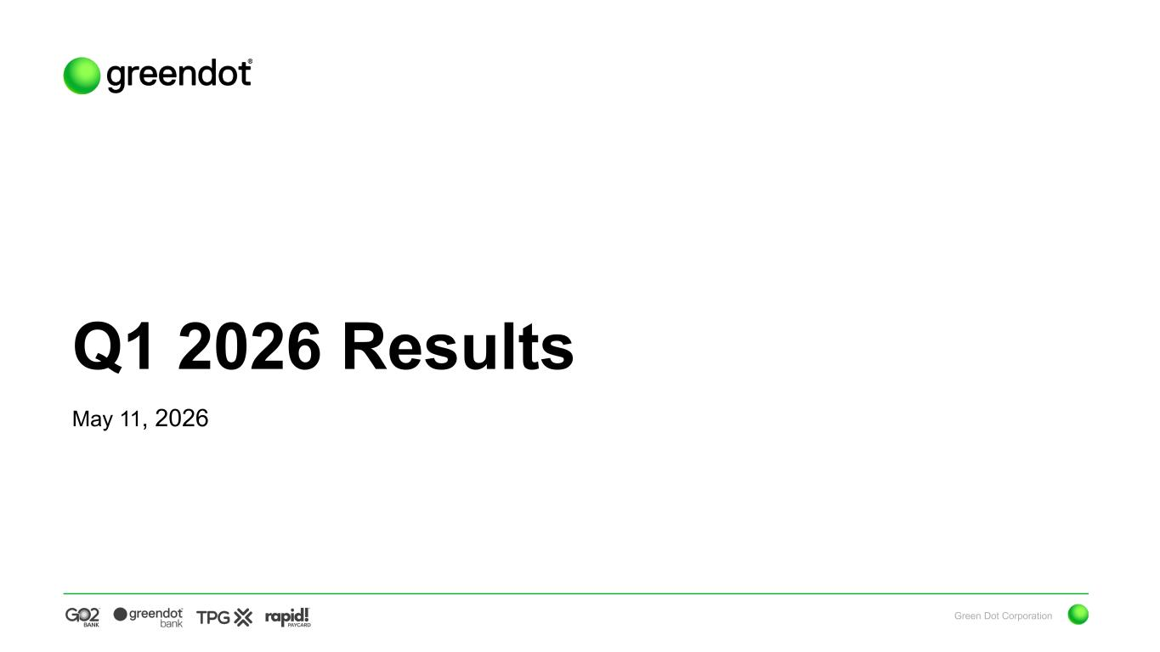

Green Dot Corporation Q1 2026 Results May 11, 2026

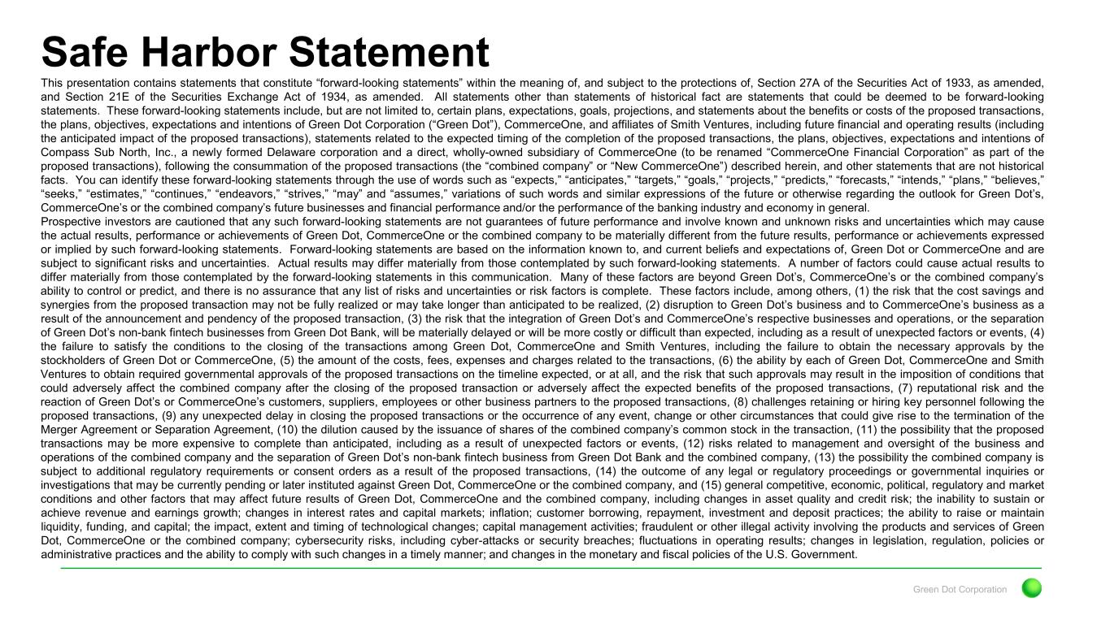
Green Dot Corporation Safe Harbor Statement This presentation contains statements that constitute “forward-looking statements” within the meaning of, and subject to the protections of, Section 27A of the Securities Act of 1933, as amended, and Section 21E of the Securities Exchange Act of 1934, as amended. All statements other than statements of historical fact are statements that could be deemed to be forward-looking statements. These forward-looking statements include, but are not limited to, certain plans, expectations, goals, projections, and statements about the benefits or costs of the proposed transactions, the plans, objectives, expectations and intentions of Green Dot Corporation (“Green Dot”), CommerceOne, and affiliates of Smith Ventures, including future financial and operating results (including the anticipated impact of the proposed transactions), statements related to the expected timing of the completion of the proposed transactions, the plans, objectives, expectations and intentions of Compass Sub North, Inc., a newly formed Delaware corporation and a direct, wholly-owned subsidiary of CommerceOne (to be renamed “CommerceOne Financial Corporation” as part of the proposed transactions), following the consummation of the proposed transactions (the “combined company” or “New CommerceOne”) described herein, and other statements that are not historical facts. You can identify these forward-looking statements through the use of words such as “expects,” “anticipates,” “targets,” “goals,” “projects,” “predicts,” “forecasts,” “intends,” “plans,” “believes,” “seeks,” “estimates,” “continues,” “endeavors,” “strives,” “may” and “assumes,” variations of such words and similar expressions of the future or otherwise regarding the outlook for Green Dot’s, CommerceOne’s or the combined company’s future businesses and financial performance and/or the performance of the banking industry and economy in general. Prospective investors are cautioned that any such forward-looking statements are not guarantees of future performance and involve known and unknown risks and uncertainties which may cause the actual results, performance or achievements of Green Dot, CommerceOne or the combined company to be materially different from the future results, performance or achievements expressed or implied by such forward-looking statements. Forward-looking statements are based on the information known to, and current beliefs and expectations of, Green Dot or CommerceOne and are subject to significant risks and uncertainties. Actual results may differ materially from those contemplated by such forward-looking statements. A number of factors could cause actual results to differ materially from those contemplated by the forward-looking statements in this communication. Many of these factors are beyond Green Dot’s, CommerceOne’s or the combined company’s ability to control or predict, and there is no assurance that any list of risks and uncertainties or risk factors is complete. These factors include, among others, (1) the risk that the cost savings and synergies from the proposed transaction may not be fully realized or may take longer than anticipated to be realized, (2) disruption to Green Dot’s business and to CommerceOne’s business as a result of the announcement and pendency of the proposed transaction, (3) the risk that the integration of Green Dot’s and CommerceOne’s respective businesses and operations, or the separation of Green Dot’s non-bank fintech businesses from Green Dot Bank, will be materially delayed or will be more costly or difficult than expected, including as a result of unexpected factors or events, (4) the failure to satisfy the conditions to the closing of the transactions among Green Dot, CommerceOne and Smith Ventures, including the failure to obtain the necessary approvals by the stockholders of Green Dot or CommerceOne, (5) the amount of the costs, fees, expenses and charges related to the transactions, (6) the ability by each of Green Dot, CommerceOne and Smith Ventures to obtain required governmental approvals of the proposed transactions on the timeline expected, or at all, and the risk that such approvals may result in the imposition of conditions that could adversely affect the combined company after the closing of the proposed transaction or adversely affect the expected benefits of the proposed transactions, (7) reputational risk and the reaction of Green Dot’s or CommerceOne’s customers, suppliers, employees or other business partners to the proposed transactions, (8) challenges retaining or hiring key personnel following the proposed transactions, (9) any unexpected delay in closing the proposed transactions or the occurrence of any event, change or other circumstances that could give rise to the termination of the Merger Agreement or Separation Agreement, (10) the dilution caused by the issuance of shares of the combined company’s common stock in the transaction, (11) the possibility that the proposed transactions may be more expensive to complete than anticipated, including as a result of unexpected factors or events, (12) risks related to management and oversight of the business and operations of the combined company and the separation of Green Dot’s non-bank fintech business from Green Dot Bank and the combined company, (13) the possibility the combined company is subject to additional regulatory requirements or consent orders as a result of the proposed transactions, (14) the outcome of any legal or regulatory proceedings or governmental inquiries or investigations that may be currently pending or later instituted against Green Dot, CommerceOne or the combined company, and (15) general competitive, economic, political, regulatory and market conditions and other factors that may affect future results of Green Dot, CommerceOne and the combined company, including changes in asset quality and credit risk; the inability to sustain or achieve revenue and earnings growth; changes in interest rates and capital markets; inflation; customer borrowing, repayment, investment and deposit practices; the ability to raise or maintain liquidity, funding, and capital; the impact, extent and timing of technological changes; capital management activities; fraudulent or other illegal activity involving the products and services of Green Dot, CommerceOne or the combined company; cybersecurity risks, including cyber-attacks or security breaches; fluctuations in operating results; changes in legislation, regulation, policies or administrative practices and the ability to comply with such changes in a timely manner; and changes in the monetary and fiscal policies of the U.S. Government.

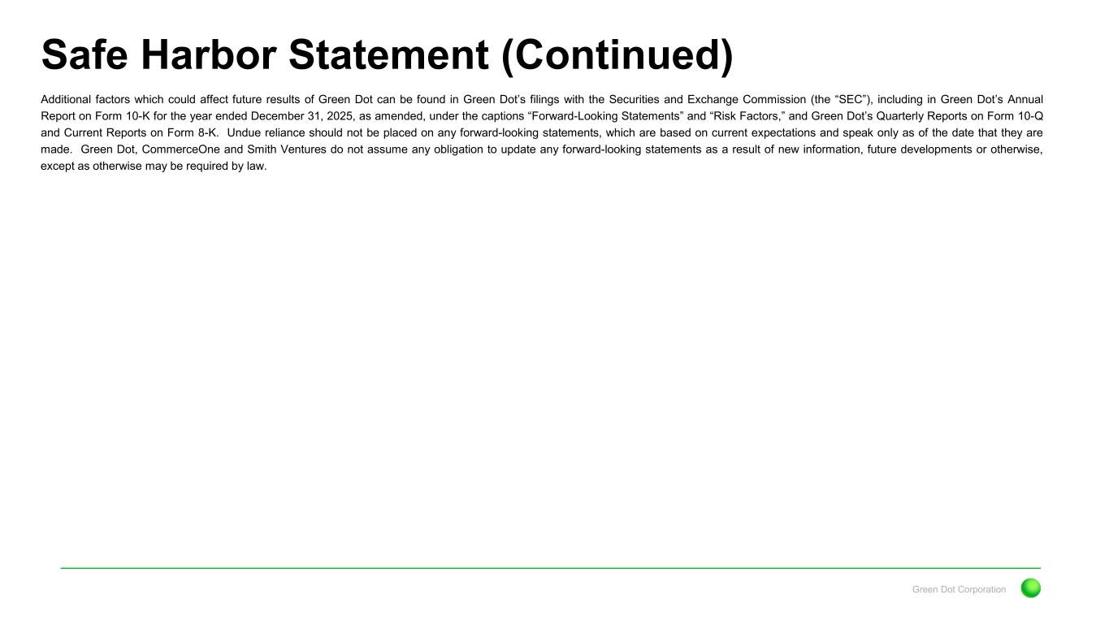
Green Dot Corporation Safe Harbor Statement (Continued) Additional factors which could affect future results of Green Dot can be found in Green Dot’s filings with the Securities and Exchange Commission (the “SEC”), including in Green Dot’s Annual Report on Form 10-K for the year ended December 31, 2025, as amended, under the captions “Forward-Looking Statements” and “Risk Factors,” and Green Dot’s Quarterly Reports on Form 10-Q and Current Reports on Form 8-K. Undue reliance should not be placed on any forward-looking statements, which are based on current expectations and speak only as of the date that they are made. Green Dot, CommerceOne and Smith Ventures do not assume any obligation to update any forward-looking statements as a result of new information, future developments or otherwise, except as otherwise may be required by law.

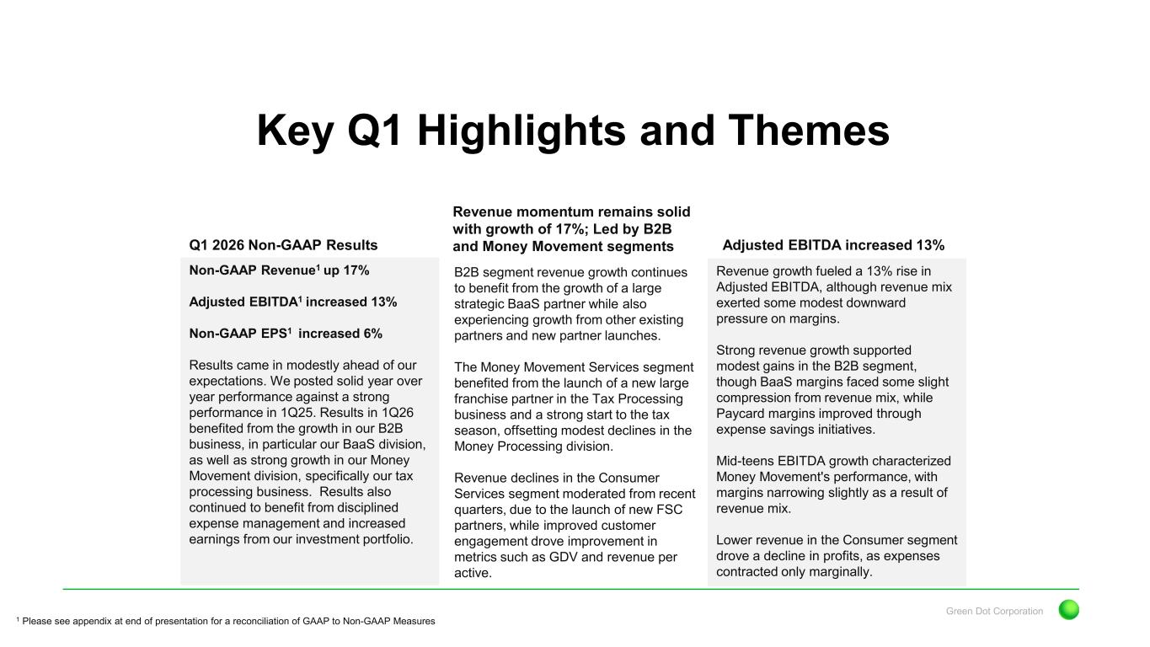
Green Dot Corporation Revenue momentum remains solid with growth of 17%; Led by B2B and Money Movement segments Key Q1 Highlights and Themes Q1 2026 Non-GAAP Results Non-GAAP Revenue1 up 17% Adjusted EBITDA1 increased 13% Non-GAAP EPS1 increased 6% Results came in modestly ahead of our expectations. We posted solid year over year performance against a strong performance in 1Q25. Results in 1Q26 benefited from the growth in our B2B business, in particular our BaaS division, as well as strong growth in our Money Movement division, specifically our tax processing business. Results also continued to benefit from disciplined expense management and increased earnings from our investment portfolio. Adjusted EBITDA increased 13% Revenue growth fueled a 13% rise in Adjusted EBITDA, although revenue mix exerted some modest downward pressure on margins. Strong revenue growth supported modest gains in the B2B segment, though BaaS margins faced some slight compression from revenue mix, while Paycard margins improved through expense savings initiatives. Mid-teens EBITDA growth characterized Money Movement's performance, with margins narrowing slightly as a result of revenue mix. Lower revenue in the Consumer segment drove a decline in profits, as expenses contracted only marginally. 1 Please see appendix at end of presentation for a reconciliation of GAAP to Non-GAAP Measures B2B segment revenue growth continues to benefit from the growth of a large strategic BaaS partner while also experiencing growth from other existing partners and new partner launches. The Money Movement Services segment benefited from the launch of a new large franchise partner in the Tax Processing business and a strong start to the tax season, offsetting modest declines in the Money Processing division. Revenue declines in the Consumer Services segment moderated from recent quarters, due to the launch of new FSC partners, while improved customer engagement drove improvement in metrics such as GDV and revenue per active.

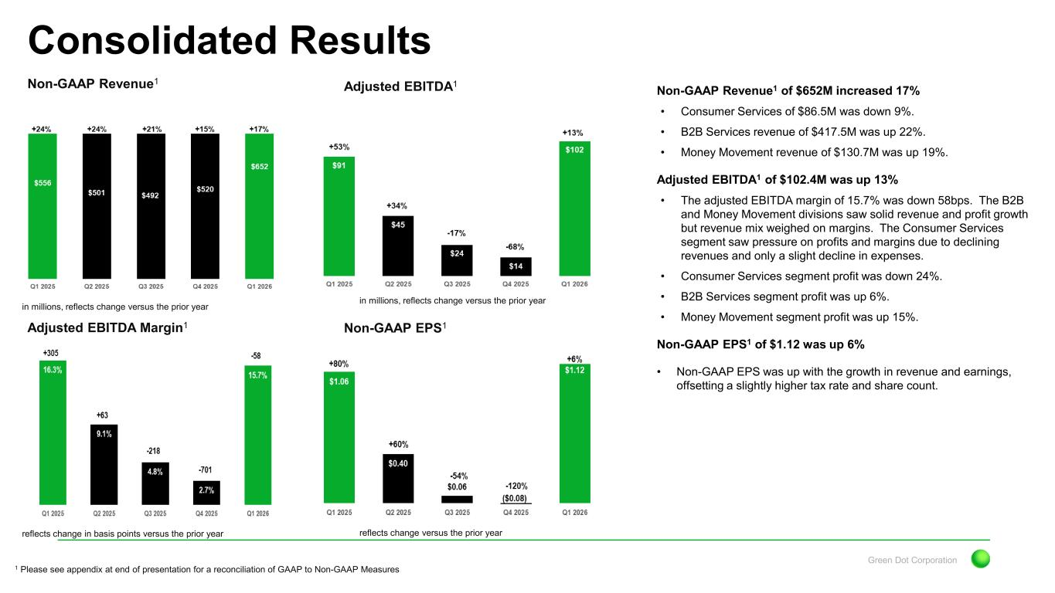
Green Dot Corporation Non-GAAP Revenue1 of $652M increased 17% • Consumer Services of $86.5M was down 9%. • B2B Services revenue of $417.5M was up 22%. • Money Movement revenue of $130.7M was up 19%. Adjusted EBITDA1 of $102.4M was up 13% • The adjusted EBITDA margin of 15.7% was down 58bps. The B2B and Money Movement divisions saw solid revenue and profit growth but revenue mix weighed on margins. The Consumer Services segment saw pressure on profits and margins due to declining revenues and only a slight decline in expenses. • Consumer Services segment profit was down 24%. • B2B Services segment profit was up 6%. • Money Movement segment profit was up 15%. Non-GAAP EPS1 of $1.12 was up 6% • Non-GAAP EPS was up with the growth in revenue and earnings, offsetting a slightly higher tax rate and share count. Non-GAAP Revenue1 Consolidated Results Adjusted EBITDA1 Adjusted EBITDA Margin1 Non-GAAP EPS1 in millions, reflects change versus the prior year in millions, reflects change versus the prior year reflects change in basis points versus the prior year reflects change versus the prior year 1 Please see appendix at end of presentation for a reconciliation of GAAP to Non-GAAP Measures

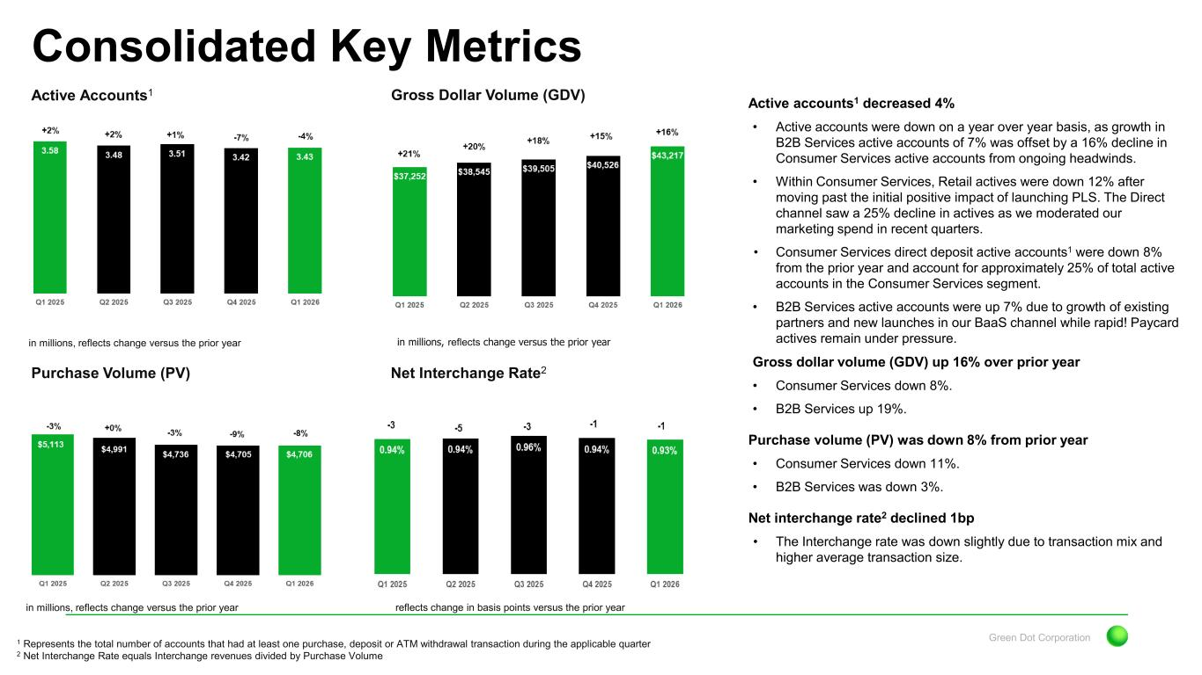
Green Dot Corporation Active accounts1 decreased 4% • Active accounts were down on a year over year basis, as growth in B2B Services active accounts of 7% was offset by a 16% decline in Consumer Services active accounts from ongoing headwinds. • Within Consumer Services, Retail actives were down 12% after moving past the initial positive impact of launching PLS. The Direct channel saw a 25% decline in actives as we moderated our marketing spend in recent quarters. • Consumer Services direct deposit active accounts1 were down 8% from the prior year and account for approximately 25% of total active accounts in the Consumer Services segment. • B2B Services active accounts were up 7% due to growth of existing partners and new launches in our BaaS channel while rapid! Paycard actives remain under pressure. Gross dollar volume (GDV) up 16% over prior year • Consumer Services down 8%. • B2B Services up 19%. Purchase volume (PV) was down 8% from prior year • Consumer Services down 11%. • B2B Services was down 3%. Net interchange rate2 declined 1bp • The Interchange rate was down slightly due to transaction mix and higher average transaction size. Active Accounts1 Consolidated Key Metrics Gross Dollar Volume (GDV) Purchase Volume (PV) Net Interchange Rate2 in millions, reflects change versus the prior year in millions, reflects change versus the prior year in millions, reflects change versus the prior year reflects change in basis points versus the prior year 1 Represents the total number of accounts that had at least one purchase, deposit or ATM withdrawal transaction during the applicable quarter 2 Net Interchange Rate equals Interchange revenues divided by Purchase Volume

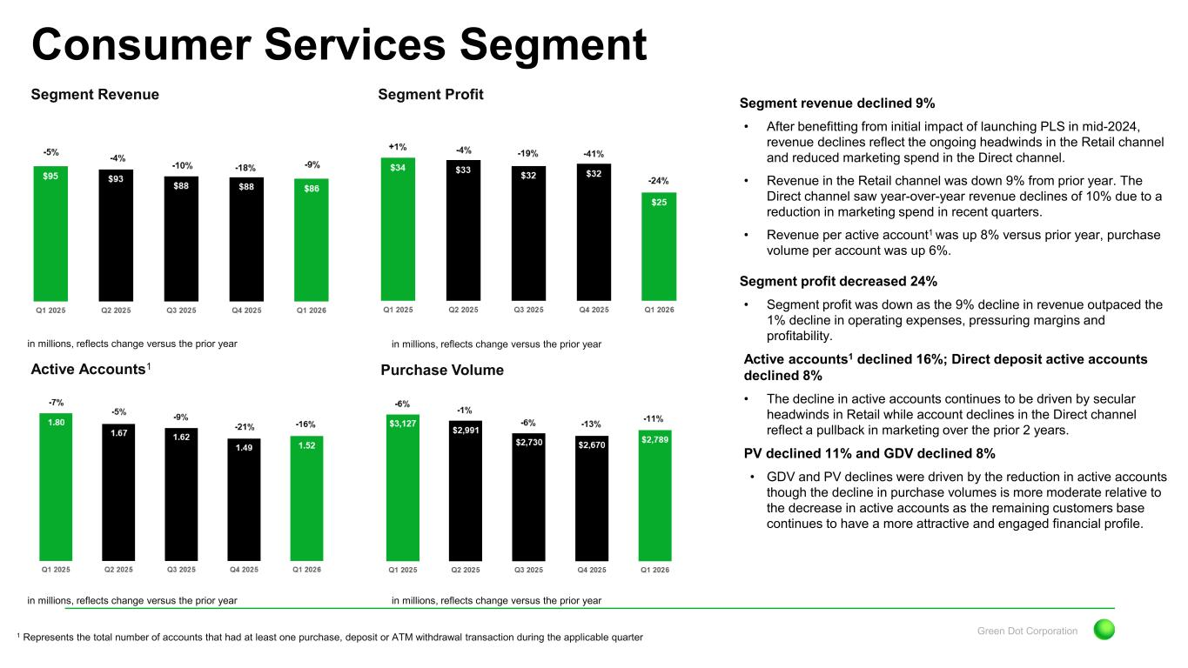
Green Dot Corporation Segment Revenue Consumer Services Segment Segment Profit Active Accounts1 Purchase Volume in millions, reflects change versus the prior year in millions, reflects change versus the prior year in millions, reflects change versus the prior year in millions, reflects change versus the prior year Segment revenue declined 9% • After benefitting from initial impact of launching PLS in mid-2024, revenue declines reflect the ongoing headwinds in the Retail channel and reduced marketing spend in the Direct channel. • Revenue in the Retail channel was down 9% from prior year. The Direct channel saw year-over-year revenue declines of 10% due to a reduction in marketing spend in recent quarters. • Revenue per active account1 was up 8% versus prior year, purchase volume per account was up 6%. Segment profit decreased 24% • Segment profit was down as the 9% decline in revenue outpaced the 1% decline in operating expenses, pressuring margins and profitability. Active accounts1 declined 16%; Direct deposit active accounts declined 8% • The decline in active accounts continues to be driven by secular headwinds in Retail while account declines in the Direct channel reflect a pullback in marketing over the prior 2 years. PV declined 11% and GDV declined 8% • GDV and PV declines were driven by the reduction in active accounts though the decline in purchase volumes is more moderate relative to the decrease in active accounts as the remaining customers base continues to have a more attractive and engaged financial profile. 1 Represents the total number of accounts that had at least one purchase, deposit or ATM withdrawal transaction during the applicable quarter

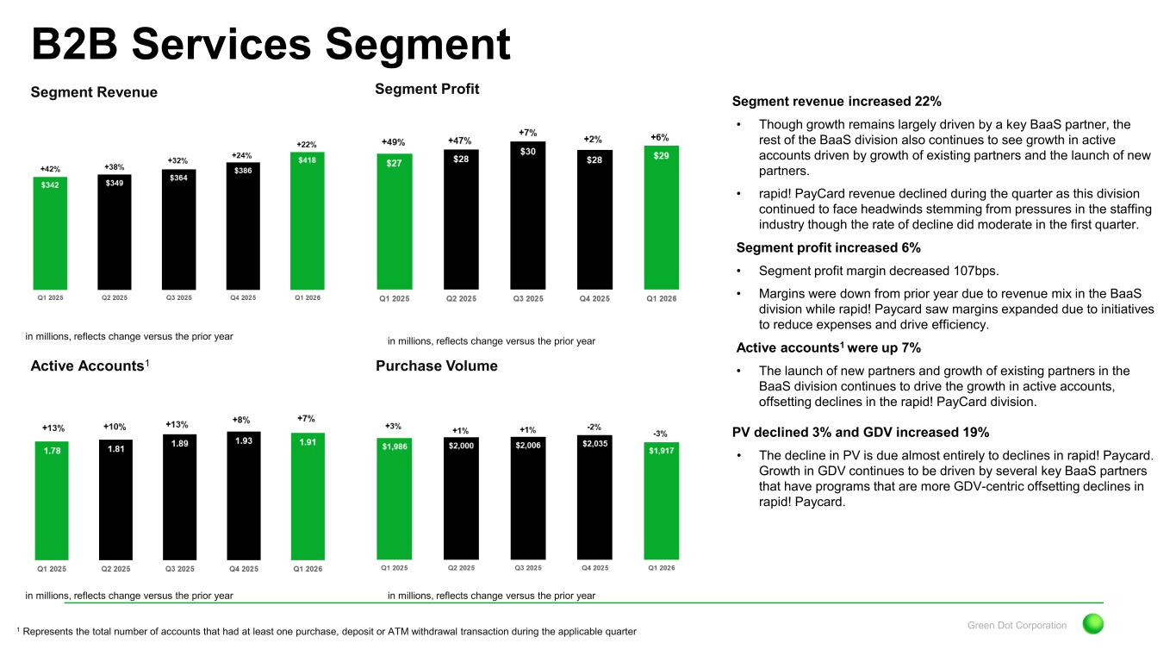
Green Dot Corporation Segment Revenue B2B Services Segment Segment Profit Active Accounts1 Purchase Volume in millions, reflects change versus the prior year in millions, reflects change versus the prior year in millions, reflects change versus the prior year in millions, reflects change versus the prior year Segment revenue increased 22% • Though growth remains largely driven by a key BaaS partner, the rest of the BaaS division also continues to see growth in active accounts driven by growth of existing partners and the launch of new partners. • rapid! PayCard revenue declined during the quarter as this division continued to face headwinds stemming from pressures in the staffing industry though the rate of decline did moderate in the first quarter. Segment profit increased 6% • Segment profit margin decreased 107bps. • Margins were down from prior year due to revenue mix in the BaaS division while rapid! Paycard saw margins expanded due to initiatives to reduce expenses and drive efficiency. Active accounts1 were up 7% • The launch of new partners and growth of existing partners in the BaaS division continues to drive the growth in active accounts, offsetting declines in the rapid! PayCard division. PV declined 3% and GDV increased 19% • The decline in PV is due almost entirely to declines in rapid! Paycard. Growth in GDV continues to be driven by several key BaaS partners that have programs that are more GDV-centric offsetting declines in rapid! Paycard. 1 Represents the total number of accounts that had at least one purchase, deposit or ATM withdrawal transaction during the applicable quarter

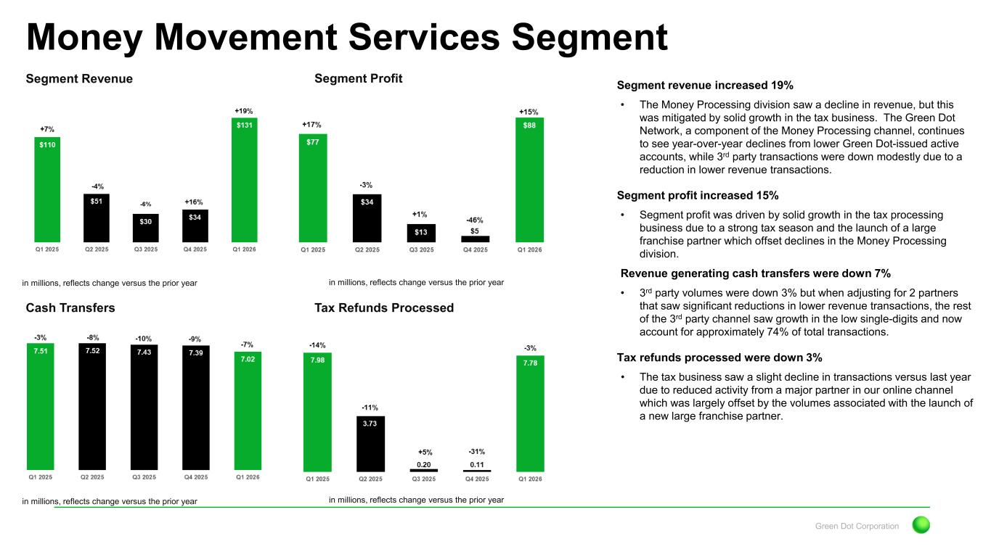
Green Dot Corporation Segment Revenue Money Movement Services Segment Segment Profit Cash Transfers Tax Refunds Processed in millions, reflects change versus the prior year in millions, reflects change versus the prior year in millions, reflects change versus the prior year in millions, reflects change versus the prior year Segment revenue increased 19% • The Money Processing division saw a decline in revenue, but this was mitigated by solid growth in the tax business. The Green Dot Network, a component of the Money Processing channel, continues to see year-over-year declines from lower Green Dot-issued active accounts, while 3rd party transactions were down modestly due to a reduction in lower revenue transactions. Segment profit increased 15% • Segment profit was driven by solid growth in the tax processing business due to a strong tax season and the launch of a large franchise partner which offset declines in the Money Processing division. Revenue generating cash transfers were down 7% • 3rd party volumes were down 3% but when adjusting for 2 partners that saw significant reductions in lower revenue transactions, the rest of the 3rd party channel saw growth in the low single-digits and now account for approximately 74% of total transactions. Tax refunds processed were down 3% • The tax business saw a slight decline in transactions versus last year due to reduced activity from a major partner in our online channel which was largely offset by the volumes associated with the launch of a new large franchise partner.

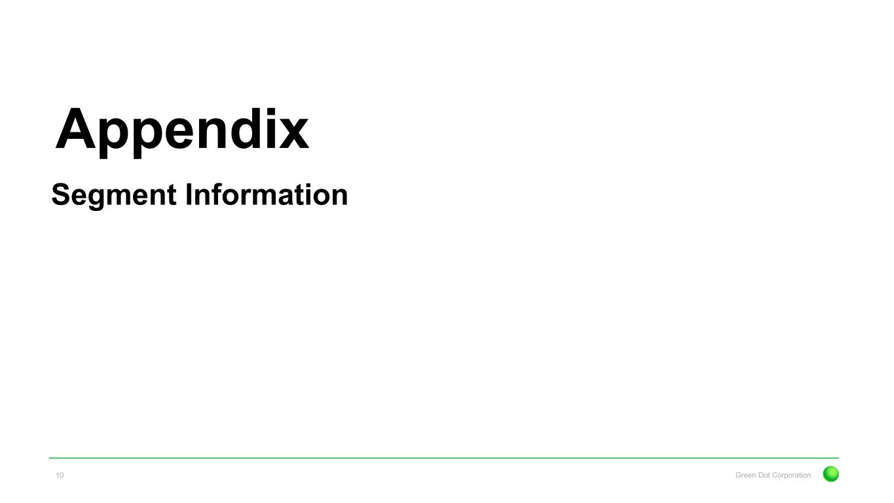
Appendix Green Dot Corporation10 Segment Information

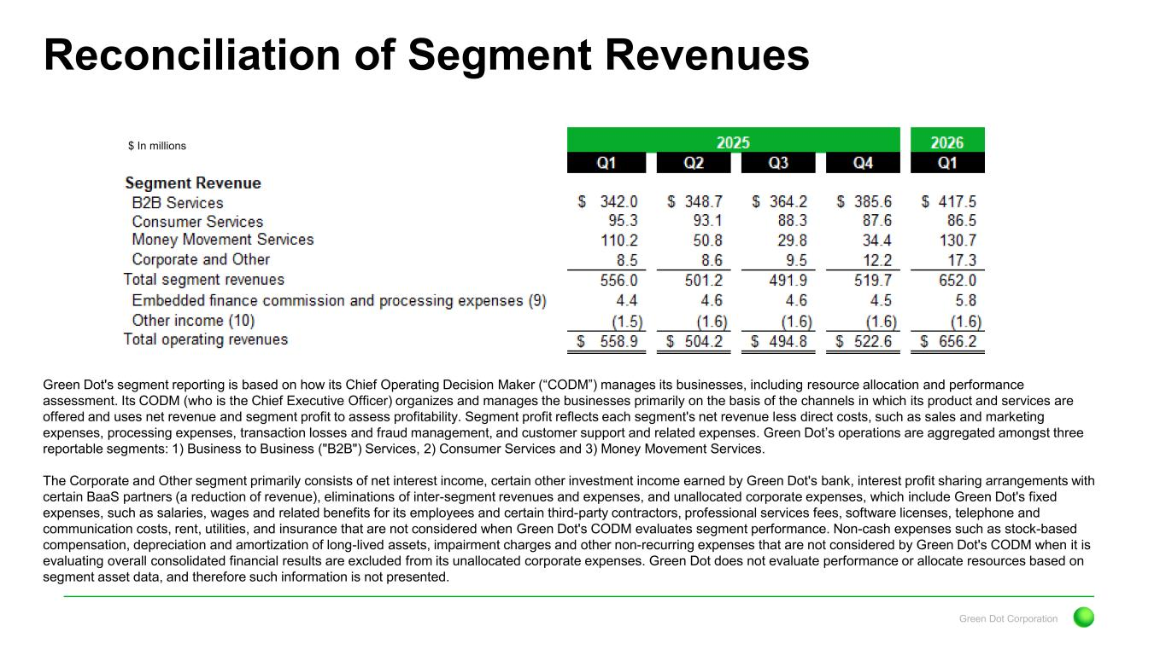
Green Dot Corporation Reconciliation of Segment Revenues Green Dot's segment reporting is based on how its Chief Operating Decision Maker (“CODM”) manages its businesses, including resource allocation and performance assessment. Its CODM (who is the Chief Executive Officer) organizes and manages the businesses primarily on the basis of the channels in which its product and services are offered and uses net revenue and segment profit to assess profitability. Segment profit reflects each segment's net revenue less direct costs, such as sales and marketing expenses, processing expenses, transaction losses and fraud management, and customer support and related expenses. Green Dot’s operations are aggregated amongst three reportable segments: 1) Business to Business ("B2B") Services, 2) Consumer Services and 3) Money Movement Services. The Corporate and Other segment primarily consists of net interest income, certain other investment income earned by Green Dot's bank, interest profit sharing arrangements with certain BaaS partners (a reduction of revenue), eliminations of inter-segment revenues and expenses, and unallocated corporate expenses, which include Green Dot's fixed expenses, such as salaries, wages and related benefits for its employees and certain third-party contractors, professional services fees, software licenses, telephone and communication costs, rent, utilities, and insurance that are not considered when Green Dot's CODM evaluates segment performance. Non-cash expenses such as stock-based compensation, depreciation and amortization of long-lived assets, impairment charges and other non-recurring expenses that are not considered by Green Dot's CODM when it is evaluating overall consolidated financial results are excluded from its unallocated corporate expenses. Green Dot does not evaluate performance or allocate resources based on segment asset data, and therefore such information is not presented. $ In millions

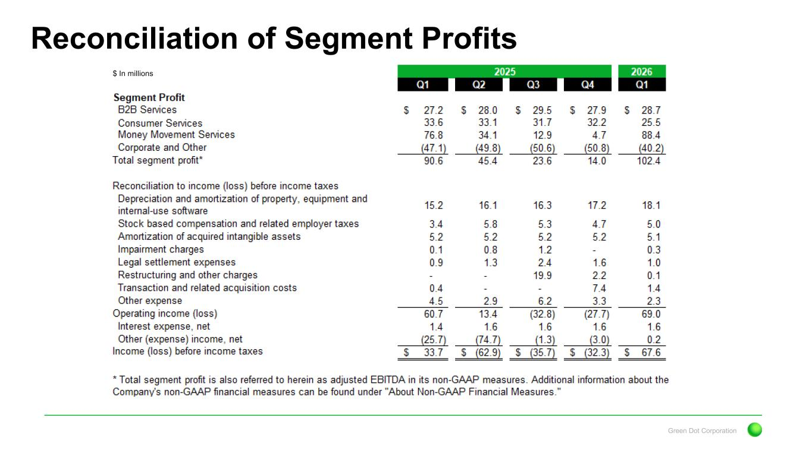
Green Dot Corporation Reconciliation of Segment Profits $ In millions

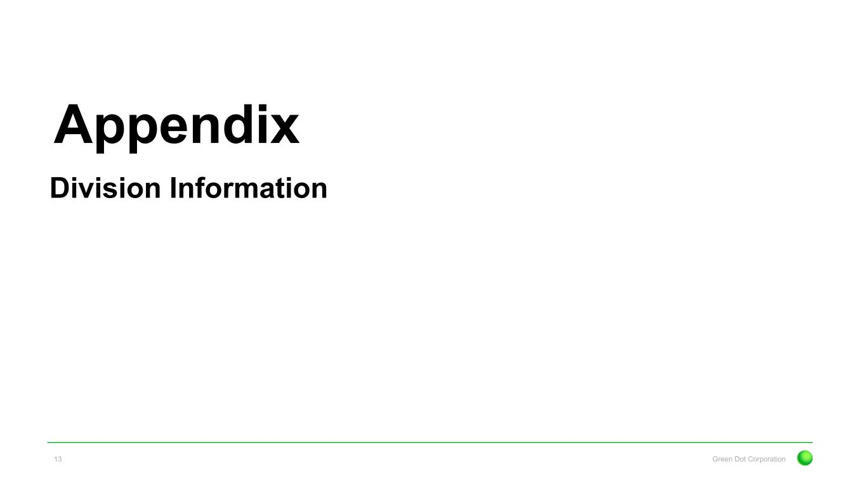
Appendix Green Dot Corporation13 Division Information

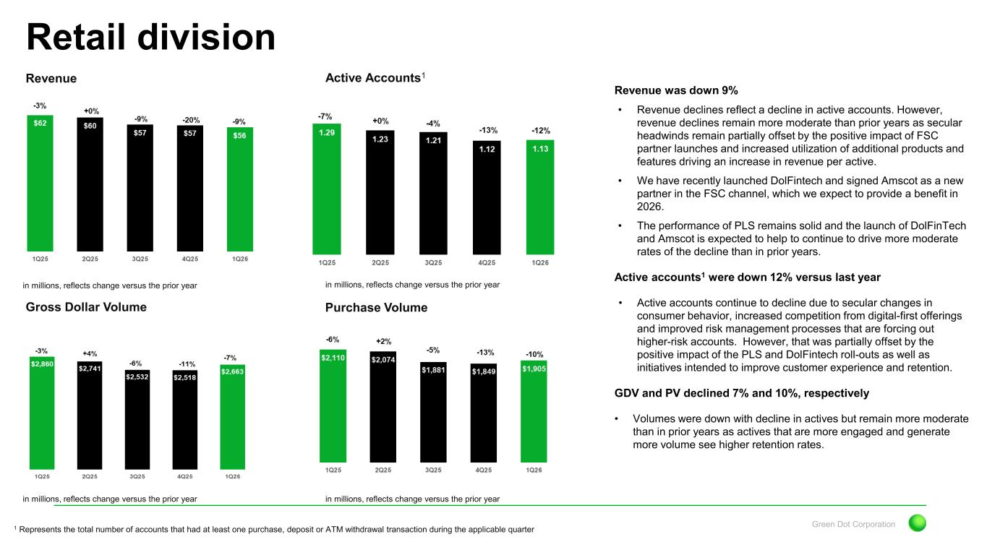
Green Dot Corporation Revenue Retail division Gross Dollar Volume Active Accounts1 Purchase Volume in millions, reflects change versus the prior year in millions, reflects change versus the prior year in millions, reflects change versus the prior year in millions, reflects change versus the prior year Revenue was down 9% • Revenue declines reflect a decline in active accounts. However, revenue declines remain more moderate than prior years as secular headwinds remain partially offset by the positive impact of FSC partner launches and increased utilization of additional products and features driving an increase in revenue per active. • We have recently launched DolFintech and signed Amscot as a new partner in the FSC channel, which we expect to provide a benefit in 2026. • The performance of PLS remains solid and the launch of DolFinTech and Amscot is expected to help to continue to drive more moderate rates of the decline than in prior years. Active accounts1 were down 12% versus last year • Active accounts continue to decline due to secular changes in consumer behavior, increased competition from digital-first offerings and improved risk management processes that are forcing out higher-risk accounts. However, that was partially offset by the positive impact of the PLS and DolFintech roll-outs as well as initiatives intended to improve customer experience and retention. GDV and PV declined 7% and 10%, respectively • Volumes were down with decline in actives but remain more moderate than in prior years as actives that are more engaged and generate more volume see higher retention rates. 1 Represents the total number of accounts that had at least one purchase, deposit or ATM withdrawal transaction during the applicable quarter

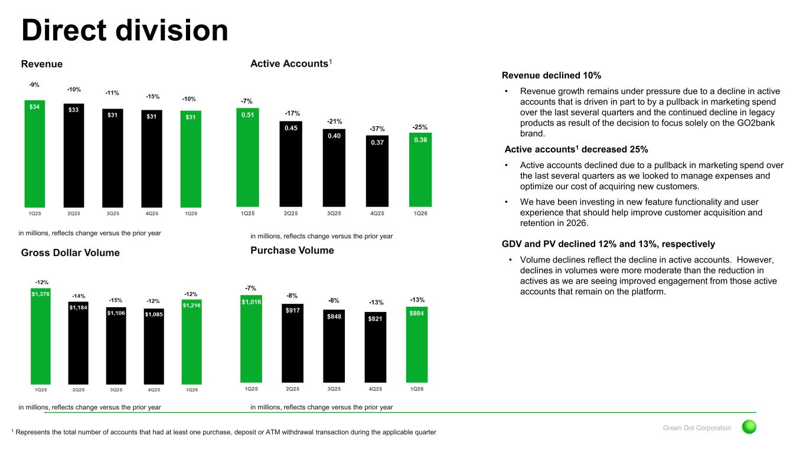
Green Dot Corporation Revenue Direct division Gross Dollar Volume Active Accounts1 Purchase Volume in millions, reflects change versus the prior year in millions, reflects change versus the prior year in millions, reflects change versus the prior year in millions, reflects change versus the prior year Revenue declined 10% • Revenue growth remains under pressure due to a decline in active accounts that is driven in part to by a pullback in marketing spend over the last several quarters and the continued decline in legacy products as result of the decision to focus solely on the GO2bank brand. Active accounts1 decreased 25% • Active accounts declined due to a pullback in marketing spend over the last several quarters as we looked to manage expenses and optimize our cost of acquiring new customers. • We have been investing in new feature functionality and user experience that should help improve customer acquisition and retention in 2026. GDV and PV declined 12% and 13%, respectively • Volume declines reflect the decline in active accounts. However, declines in volumes were more moderate than the reduction in actives as we are seeing improved engagement from those active accounts that remain on the platform. 1 Represents the total number of accounts that had at least one purchase, deposit or ATM withdrawal transaction during the applicable quarter

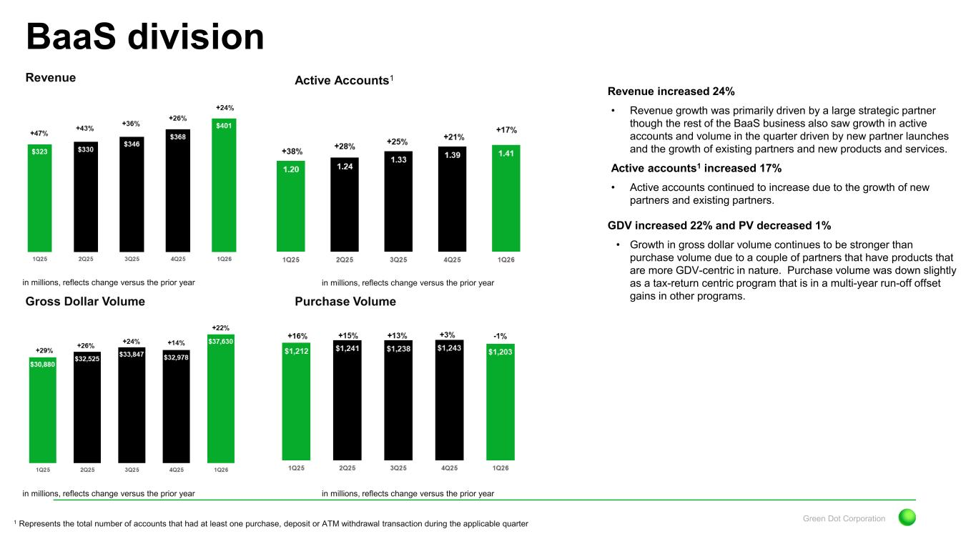
Green Dot Corporation Revenue BaaS division Gross Dollar Volume Active Accounts1 Purchase Volume in millions, reflects change versus the prior year in millions, reflects change versus the prior year in millions, reflects change versus the prior year in millions, reflects change versus the prior year Revenue increased 24% • Revenue growth was primarily driven by a large strategic partner though the rest of the BaaS business also saw growth in active accounts and volume in the quarter driven by new partner launches and the growth of existing partners and new products and services. Active accounts1 increased 17% • Active accounts continued to increase due to the growth of new partners and existing partners. GDV increased 22% and PV decreased 1% • Growth in gross dollar volume continues to be stronger than purchase volume due to a couple of partners that have products that are more GDV-centric in nature. Purchase volume was down slightly as a tax-return centric program that is in a multi-year run-off offset gains in other programs. 1 Represents the total number of accounts that had at least one purchase, deposit or ATM withdrawal transaction during the applicable quarter

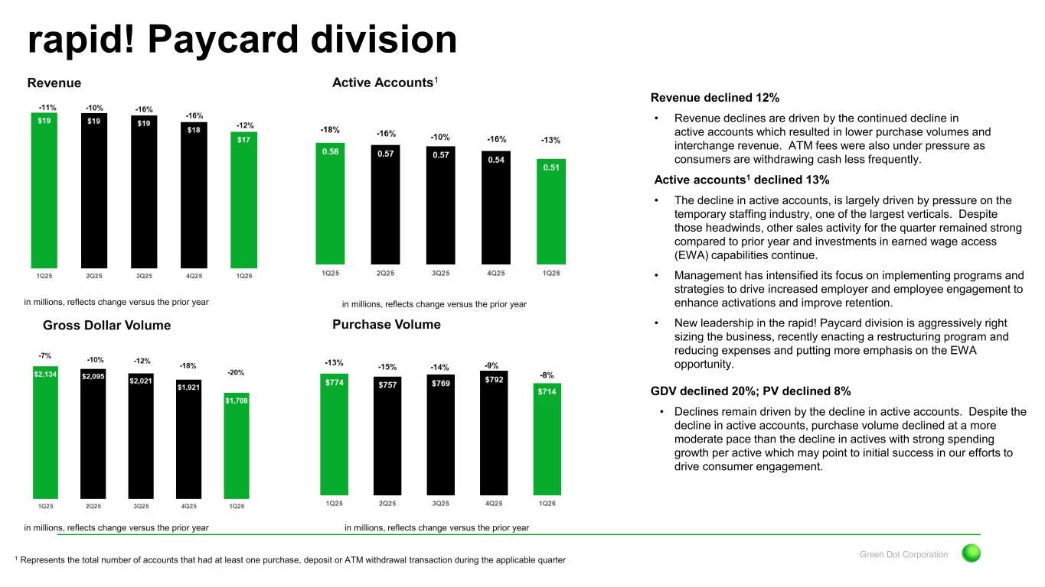
Green Dot Corporation Revenue rapid! Paycard division Gross Dollar Volume Active Accounts1 Purchase Volume in millions, reflects change versus the prior year in millions, reflects change versus the prior year in millions, reflects change versus the prior year in millions, reflects change versus the prior year Revenue declined 12% • Revenue declines are driven by the continued decline in active accounts which resulted in lower purchase volumes and interchange revenue. ATM fees were also under pressure as consumers are withdrawing cash less frequently. Active accounts1 declined 13% • The decline in active accounts, is largely driven by pressure on the temporary staffing industry, one of the largest verticals. Despite those headwinds, other sales activity for the quarter remained strong compared to prior year and investments in earned wage access (EWA) capabilities continue. • Management has intensified its focus on implementing programs and strategies to drive increased employer and employee engagement to enhance activations and improve retention. • New leadership in the rapid! Paycard division is aggressively right sizing the business, recently enacting a restructuring program and reducing expenses and putting more emphasis on the EWA opportunity. GDV declined 20%; PV declined 8% • Declines remain driven by the decline in active accounts. Despite the decline in active accounts, purchase volume declined at a more moderate pace than the decline in actives with strong spending growth per active which may point to initial success in our efforts to drive consumer engagement. 1 Represents the total number of accounts that had at least one purchase, deposit or ATM withdrawal transaction during the applicable quarter

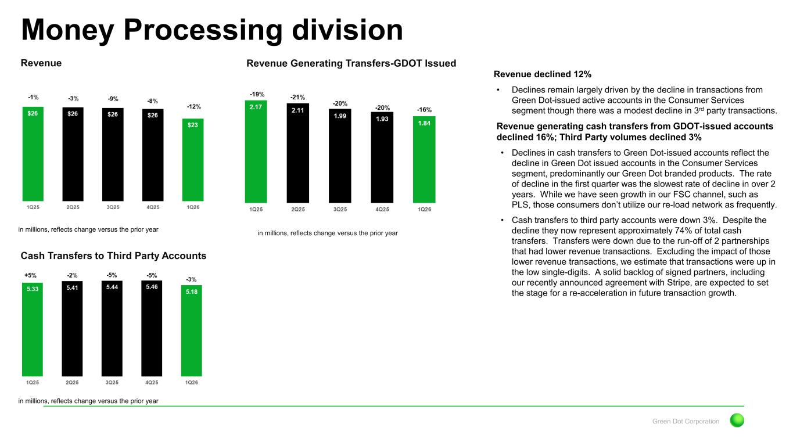
Green Dot Corporation Revenue Money Processing division Revenue Generating Transfers-GDOT Issued Cash Transfers to Third Party Accounts in millions, reflects change versus the prior year in millions, reflects change versus the prior year in millions, reflects change versus the prior year Revenue declined 12% • Declines remain largely driven by the decline in transactions from Green Dot-issued active accounts in the Consumer Services segment though there was a modest decline in 3rd party transactions. Revenue generating cash transfers from GDOT-issued accounts declined 16%; Third Party volumes declined 3% • Declines in cash transfers to Green Dot-issued accounts reflect the decline in Green Dot issued accounts in the Consumer Services segment, predominantly our Green Dot branded products. The rate of decline in the first quarter was the slowest rate of decline in over 2 years. While we have seen growth in our FSC channel, such as PLS, those consumers don’t utilize our re-load network as frequently. • Cash transfers to third party accounts were down 3%. Despite the decline they now represent approximately 74% of total cash transfers. Transfers were down due to the run-off of 2 partnerships that had lower revenue transactions. Excluding the impact of those lower revenue transactions, we estimate that transactions were up in the low single-digits. A solid backlog of signed partners, including our recently announced agreement with Stripe, are expected to set the stage for a re-acceleration in future transaction growth.

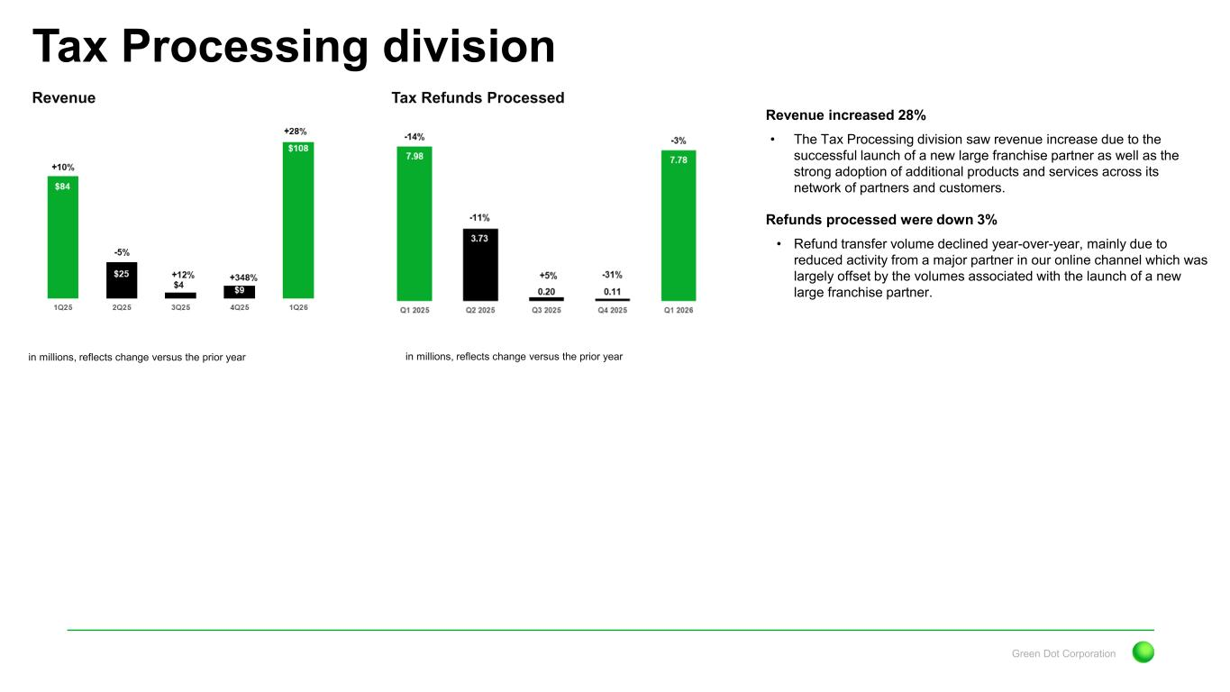
Green Dot Corporation Revenue Tax Processing division Tax Refunds Processed in millions, reflects change versus the prior year in millions, reflects change versus the prior year Revenue increased 28% • The Tax Processing division saw revenue increase due to the successful launch of a new large franchise partner as well as the strong adoption of additional products and services across its network of partners and customers. Refunds processed were down 3% • Refund transfer volume declined year-over-year, mainly due to reduced activity from a major partner in our online channel which was largely offset by the volumes associated with the launch of a new large franchise partner.

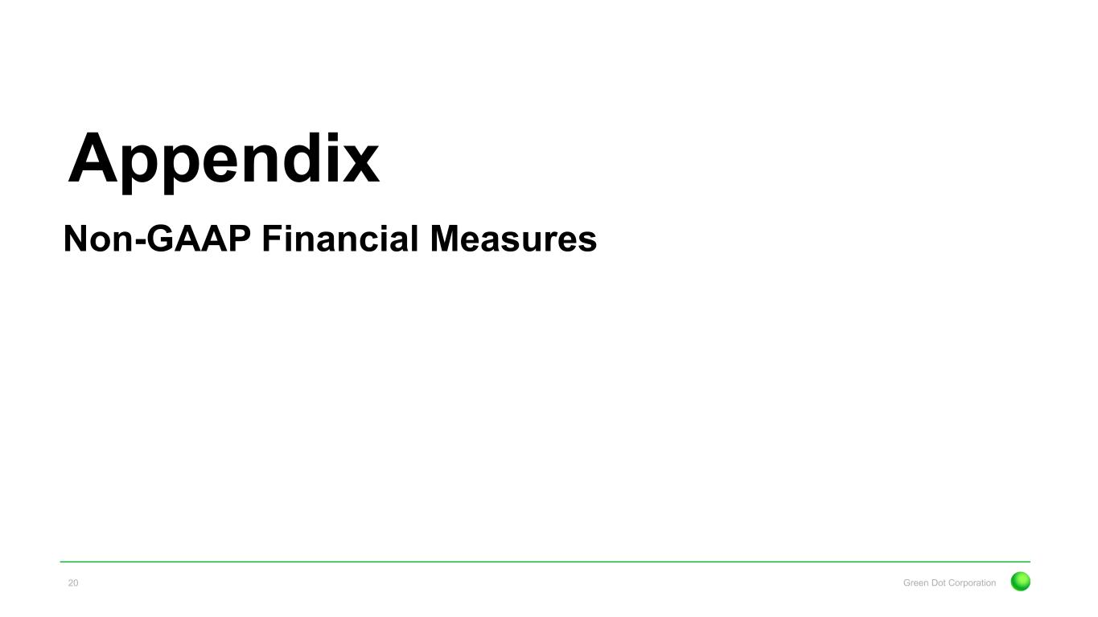
Appendix Green Dot Corporation20 Non-GAAP Financial Measures

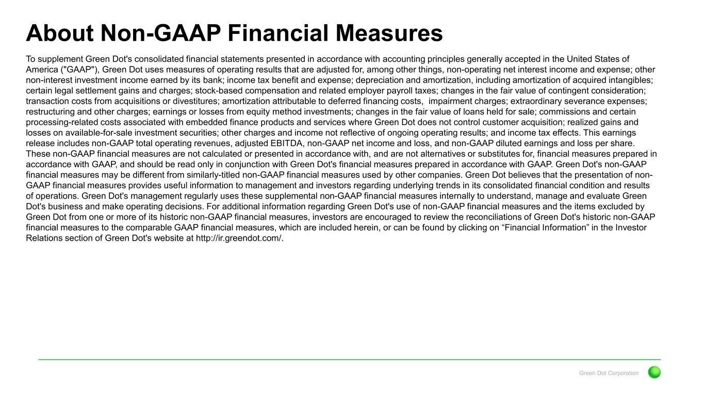
Green Dot Corporation About Non-GAAP Financial Measures To supplement Green Dot's consolidated financial statements presented in accordance with accounting principles generally accepted in the United States of America ("GAAP"), Green Dot uses measures of operating results that are adjusted for, among other things, non-operating net interest income and expense; other non-interest investment income earned by its bank; income tax benefit and expense; depreciation and amortization, including amortization of acquired intangibles; certain legal settlement gains and charges; stock-based compensation and related employer payroll taxes; changes in the fair value of contingent consideration; transaction costs from acquisitions or divestitures; amortization attributable to deferred financing costs, impairment charges; extraordinary severance expenses; restructuring and other charges; earnings or losses from equity method investments; changes in the fair value of loans held for sale; commissions and certain processing-related costs associated with embedded finance products and services where Green Dot does not control customer acquisition; realized gains and losses on available-for-sale investment securities; other charges and income not reflective of ongoing operating results; and income tax effects. This earnings release includes non-GAAP total operating revenues, adjusted EBITDA, non-GAAP net income and loss, and non-GAAP diluted earnings and loss per share. These non-GAAP financial measures are not calculated or presented in accordance with, and are not alternatives or substitutes for, financial measures prepared in accordance with GAAP, and should be read only in conjunction with Green Dot's financial measures prepared in accordance with GAAP. Green Dot's non-GAAP financial measures may be different from similarly-titled non-GAAP financial measures used by other companies. Green Dot believes that the presentation of non- GAAP financial measures provides useful information to management and investors regarding underlying trends in its consolidated financial condition and results of operations. Green Dot's management regularly uses these supplemental non-GAAP financial measures internally to understand, manage and evaluate Green Dot's business and make operating decisions. For additional information regarding Green Dot's use of non-GAAP financial measures and the items excluded by Green Dot from one or more of its historic non-GAAP financial measures, investors are encouraged to review the reconciliations of Green Dot's historic non-GAAP financial measures to the comparable GAAP financial measures, which are included herein, or can be found by clicking on “Financial Information” in the Investor Relations section of Green Dot's website at http://ir.greendot.com/.

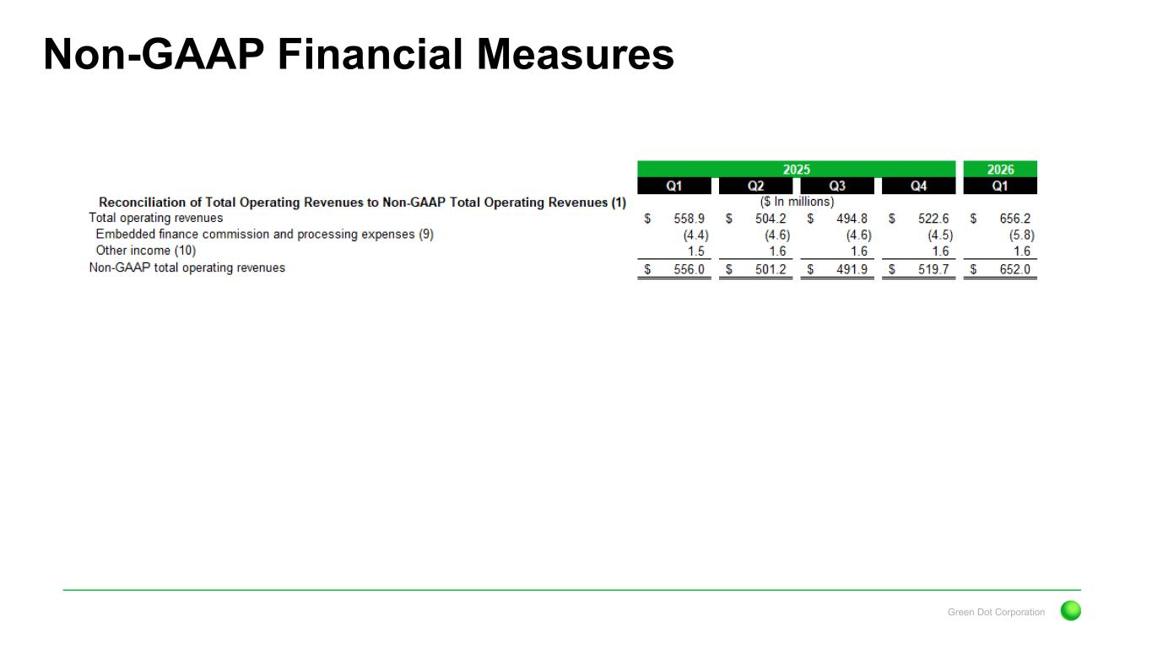
Green Dot Corporation Non-GAAP Financial Measures

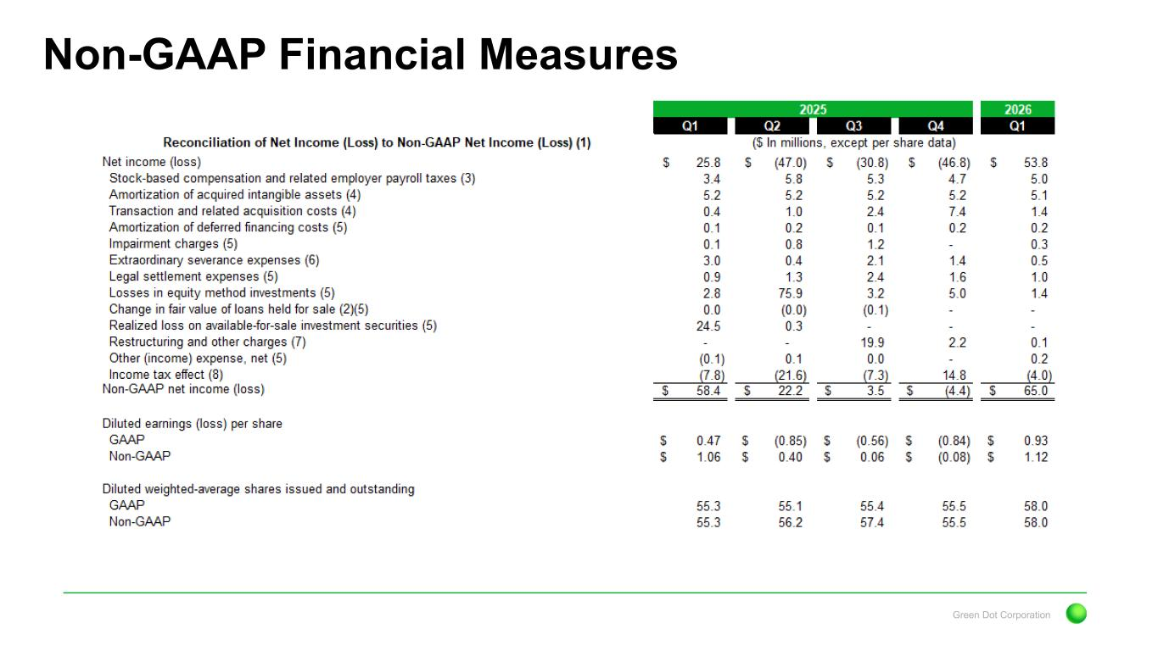
Green Dot Corporation Non-GAAP Financial Measures

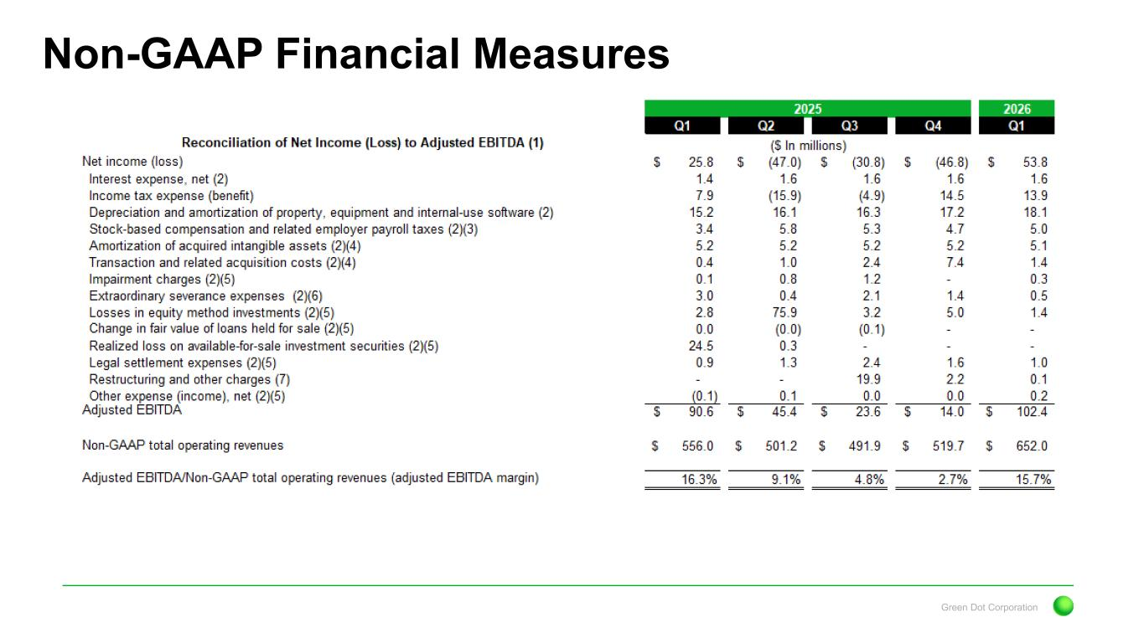
Green Dot Corporation Non-GAAP Financial Measures

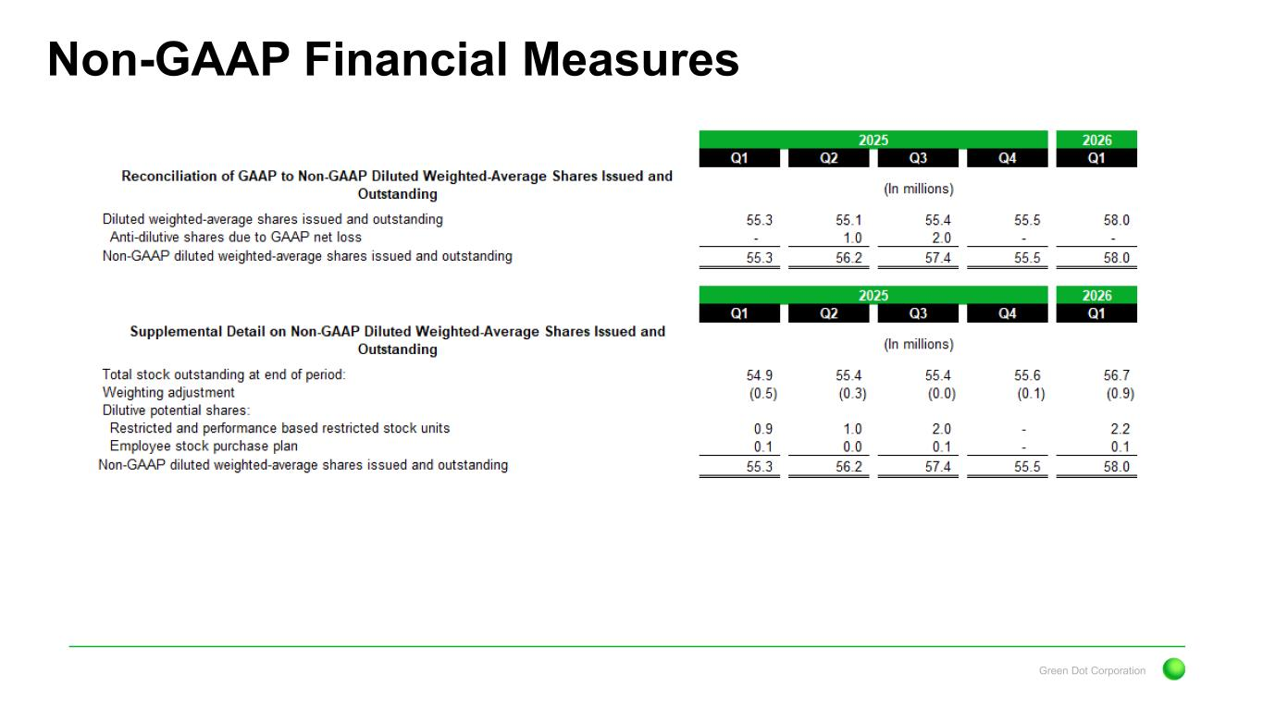
Green Dot Corporation Non-GAAP Financial Measures

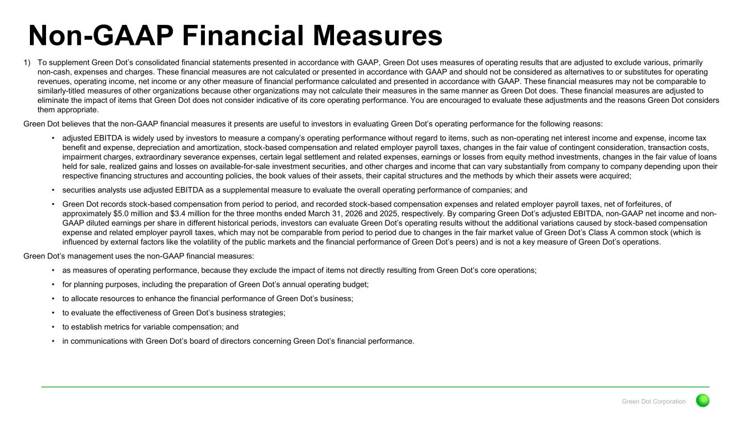
Green Dot Corporation Non-GAAP Financial Measures 1) To supplement Green Dot’s consolidated financial statements presented in accordance with GAAP, Green Dot uses measures of operating results that are adjusted to exclude various, primarily non-cash, expenses and charges. These financial measures are not calculated or presented in accordance with GAAP and should not be considered as alternatives to or substitutes for operating revenues, operating income, net income or any other measure of financial performance calculated and presented in accordance with GAAP. These financial measures may not be comparable to similarly-titled measures of other organizations because other organizations may not calculate their measures in the same manner as Green Dot does. These financial measures are adjusted to eliminate the impact of items that Green Dot does not consider indicative of its core operating performance. You are encouraged to evaluate these adjustments and the reasons Green Dot considers them appropriate. Green Dot believes that the non-GAAP financial measures it presents are useful to investors in evaluating Green Dot’s operating performance for the following reasons: • adjusted EBITDA is widely used by investors to measure a company’s operating performance without regard to items, such as non-operating net interest income and expense, income tax benefit and expense, depreciation and amortization, stock-based compensation and related employer payroll taxes, changes in the fair value of contingent consideration, transaction costs, impairment charges, extraordinary severance expenses, certain legal settlement and related expenses, earnings or losses from equity method investments, changes in the fair value of loans held for sale, realized gains and losses on available-for-sale investment securities, and other charges and income that can vary substantially from company to company depending upon their respective financing structures and accounting policies, the book values of their assets, their capital structures and the methods by which their assets were acquired; • securities analysts use adjusted EBITDA as a supplemental measure to evaluate the overall operating performance of companies; and • Green Dot records stock-based compensation from period to period, and recorded stock-based compensation expenses and related employer payroll taxes, net of forfeitures, of approximately $5.0 million and $3.4 million for the three months ended March 31, 2026 and 2025, respectively. By comparing Green Dot’s adjusted EBITDA, non-GAAP net income and non- GAAP diluted earnings per share in different historical periods, investors can evaluate Green Dot’s operating results without the additional variations caused by stock-based compensation expense and related employer payroll taxes, which may not be comparable from period to period due to changes in the fair market value of Green Dot’s Class A common stock (which is influenced by external factors like the volatility of the public markets and the financial performance of Green Dot’s peers) and is not a key measure of Green Dot’s operations. Green Dot’s management uses the non-GAAP financial measures: • as measures of operating performance, because they exclude the impact of items not directly resulting from Green Dot’s core operations; • for planning purposes, including the preparation of Green Dot’s annual operating budget; • to allocate resources to enhance the financial performance of Green Dot’s business; • to evaluate the effectiveness of Green Dot’s business strategies; • to establish metrics for variable compensation; and • in communications with Green Dot’s board of directors concerning Green Dot’s financial performance.

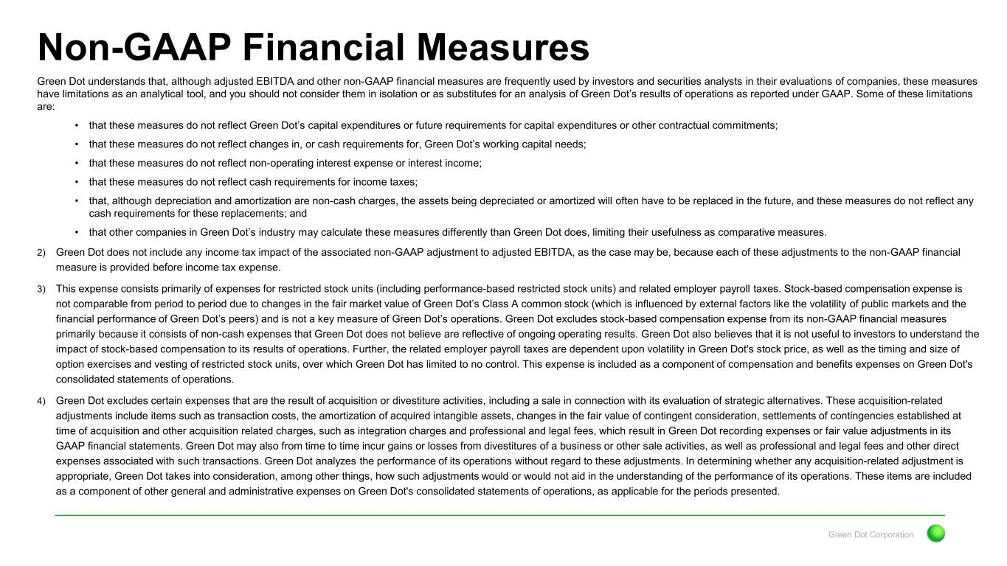
Green Dot Corporation Non-GAAP Financial Measures Green Dot understands that, although adjusted EBITDA and other non-GAAP financial measures are frequently used by investors and securities analysts in their evaluations of companies, these measures have limitations as an analytical tool, and you should not consider them in isolation or as substitutes for an analysis of Green Dot’s results of operations as reported under GAAP. Some of these limitations are: • that these measures do not reflect Green Dot’s capital expenditures or future requirements for capital expenditures or other contractual commitments; • that these measures do not reflect changes in, or cash requirements for, Green Dot’s working capital needs; • that these measures do not reflect non-operating interest expense or interest income; • that these measures do not reflect cash requirements for income taxes; • that, although depreciation and amortization are non-cash charges, the assets being depreciated or amortized will often have to be replaced in the future, and these measures do not reflect any cash requirements for these replacements; and • that other companies in Green Dot’s industry may calculate these measures differently than Green Dot does, limiting their usefulness as comparative measures. 2) Green Dot does not include any income tax impact of the associated non-GAAP adjustment to adjusted EBITDA, as the case may be, because each of these adjustments to the non-GAAP financial measure is provided before income tax expense. 3) This expense consists primarily of expenses for restricted stock units (including performance-based restricted stock units) and related employer payroll taxes. Stock-based compensation expense is not comparable from period to period due to changes in the fair market value of Green Dot’s Class A common stock (which is influenced by external factors like the volatility of public markets and the financial performance of Green Dot’s peers) and is not a key measure of Green Dot’s operations. Green Dot excludes stock-based compensation expense from its non-GAAP financial measures primarily because it consists of non-cash expenses that Green Dot does not believe are reflective of ongoing operating results. Green Dot also believes that it is not useful to investors to understand the impact of stock-based compensation to its results of operations. Further, the related employer payroll taxes are dependent upon volatility in Green Dot's stock price, as well as the timing and size of option exercises and vesting of restricted stock units, over which Green Dot has limited to no control. This expense is included as a component of compensation and benefits expenses on Green Dot's consolidated statements of operations. 4) Green Dot excludes certain expenses that are the result of acquisition or divestiture activities, including a sale in connection with its evaluation of strategic alternatives. These acquisition-related adjustments include items such as transaction costs, the amortization of acquired intangible assets, changes in the fair value of contingent consideration, settlements of contingencies established at time of acquisition and other acquisition related charges, such as integration charges and professional and legal fees, which result in Green Dot recording expenses or fair value adjustments in its GAAP financial statements. Green Dot may also from time to time incur gains or losses from divestitures of a business or other sale activities, as well as professional and legal fees and other direct expenses associated with such transactions. Green Dot analyzes the performance of its operations without regard to these adjustments. In determining whether any acquisition-related adjustment is appropriate, Green Dot takes into consideration, among other things, how such adjustments would or would not aid in the understanding of the performance of its operations. These items are included as a component of other general and administrative expenses on Green Dot's consolidated statements of operations, as applicable for the periods presented.

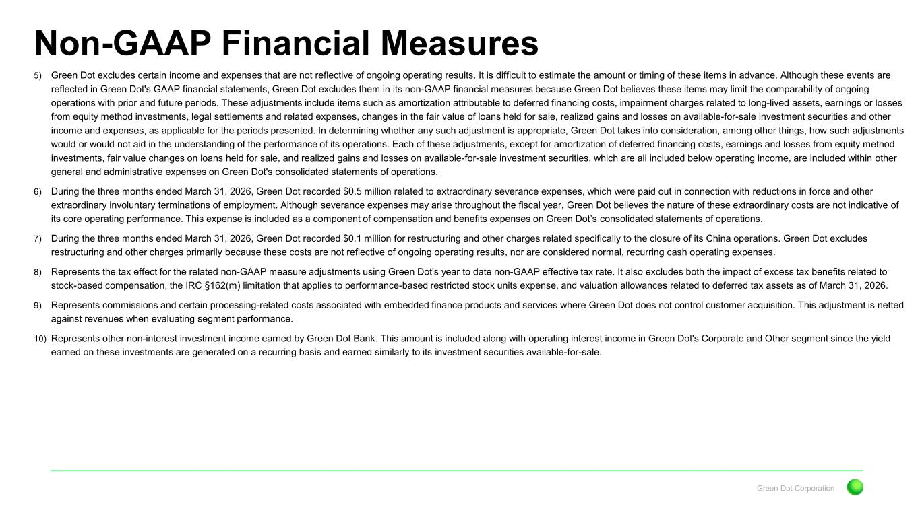
Green Dot Corporation Non-GAAP Financial Measures 5) Green Dot excludes certain income and expenses that are not reflective of ongoing operating results. It is difficult to estimate the amount or timing of these items in advance. Although these events are reflected in Green Dot's GAAP financial statements, Green Dot excludes them in its non-GAAP financial measures because Green Dot believes these items may limit the comparability of ongoing operations with prior and future periods. These adjustments include items such as amortization attributable to deferred financing costs, impairment charges related to long-lived assets, earnings or losses from equity method investments, legal settlements and related expenses, changes in the fair value of loans held for sale, realized gains and losses on available-for-sale investment securities and other income and expenses, as applicable for the periods presented. In determining whether any such adjustment is appropriate, Green Dot takes into consideration, among other things, how such adjustments would or would not aid in the understanding of the performance of its operations. Each of these adjustments, except for amortization of deferred financing costs, earnings and losses from equity method investments, fair value changes on loans held for sale, and realized gains and losses on available-for-sale investment securities, which are all included below operating income, are included within other general and administrative expenses on Green Dot's consolidated statements of operations. 6) During the three months ended March 31, 2026, Green Dot recorded $0.5 million related to extraordinary severance expenses, which were paid out in connection with reductions in force and other extraordinary involuntary terminations of employment. Although severance expenses may arise throughout the fiscal year, Green Dot believes the nature of these extraordinary costs are not indicative of its core operating performance. This expense is included as a component of compensation and benefits expenses on Green Dot’s consolidated statements of operations. 7) During the three months ended March 31, 2026, Green Dot recorded $0.1 million for restructuring and other charges related specifically to the closure of its China operations. Green Dot excludes restructuring and other charges primarily because these costs are not reflective of ongoing operating results, nor are considered normal, recurring cash operating expenses. 8) Represents the tax effect for the related non-GAAP measure adjustments using Green Dot's year to date non-GAAP effective tax rate. It also excludes both the impact of excess tax benefits related to stock-based compensation, the IRC §162(m) limitation that applies to performance-based restricted stock units expense, and valuation allowances related to deferred tax assets as of March 31, 2026. 9) Represents commissions and certain processing-related costs associated with embedded finance products and services where Green Dot does not control customer acquisition. This adjustment is netted against revenues when evaluating segment performance. 10) Represents other non-interest investment income earned by Green Dot Bank. This amount is included along with operating interest income in Green Dot's Corporate and Other segment since the yield earned on these investments are generated on a recurring basis and earned similarly to its investment securities available-for-sale.

